## SELECT from World

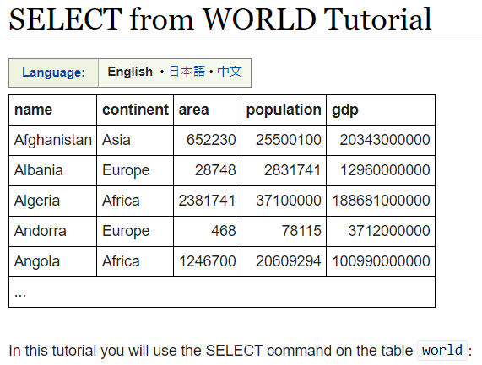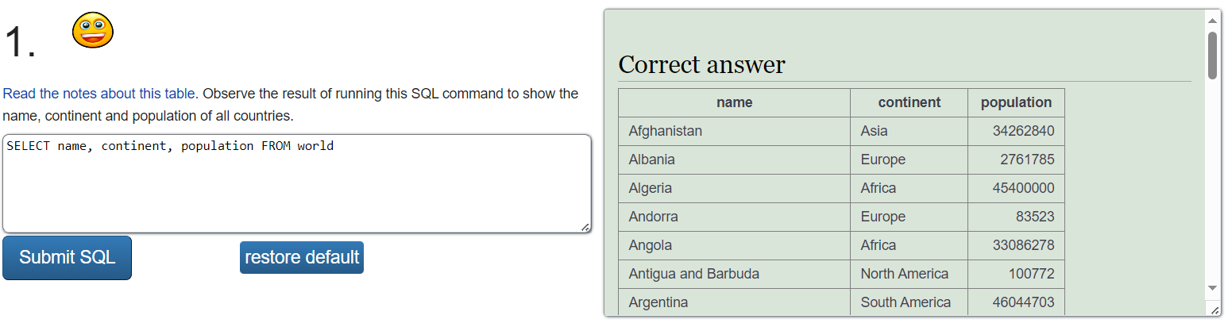

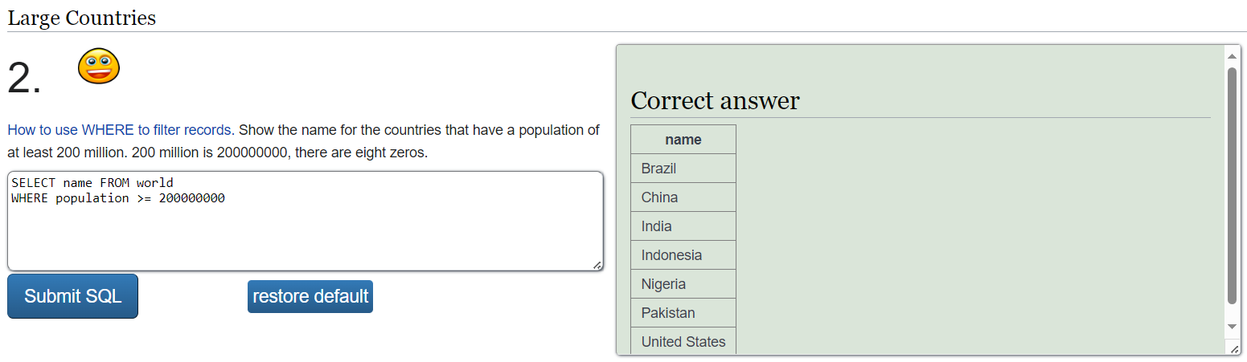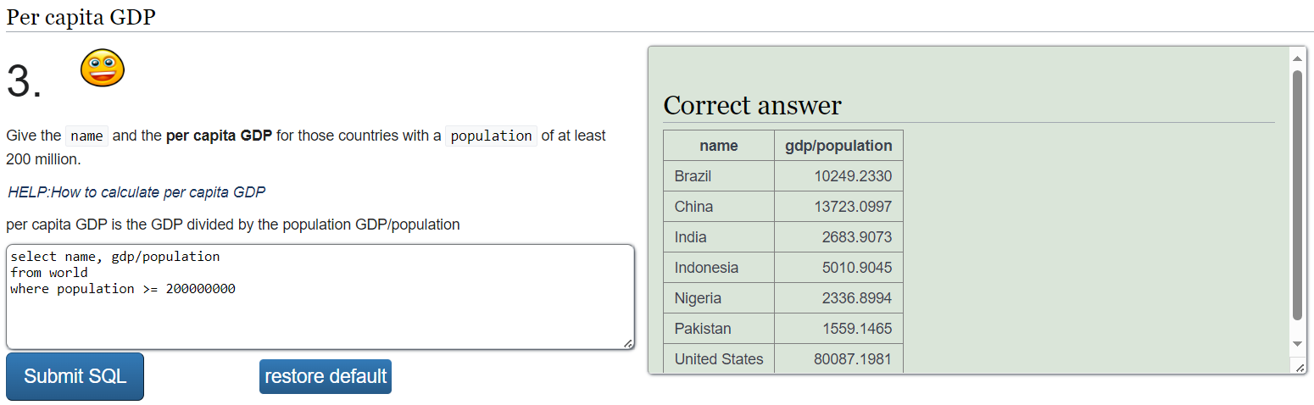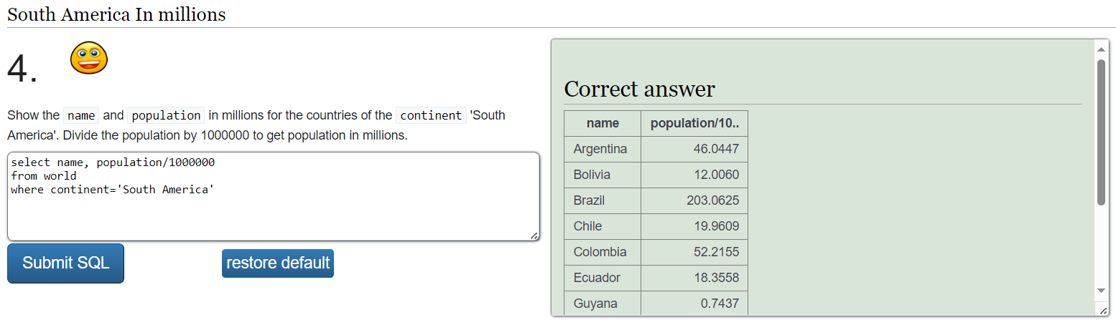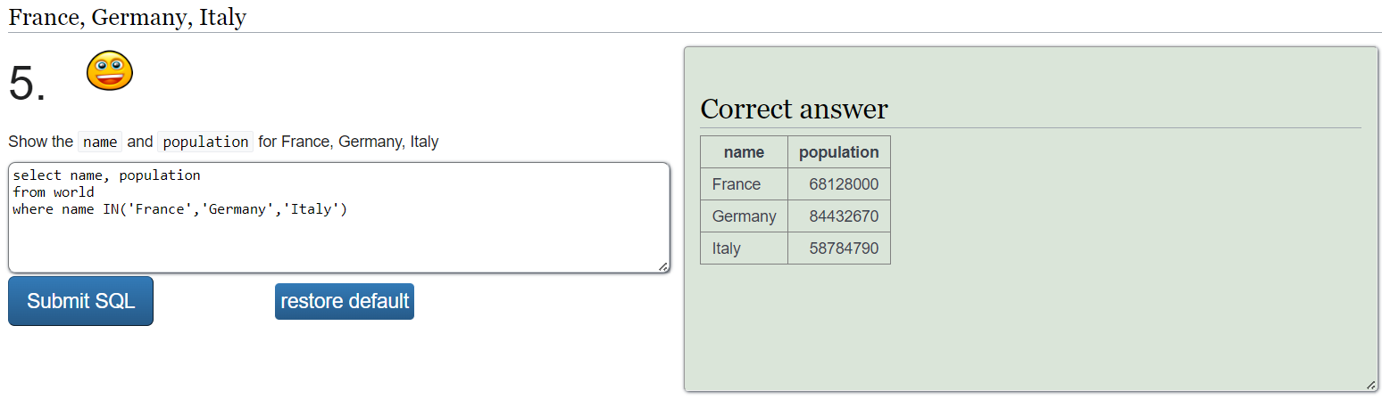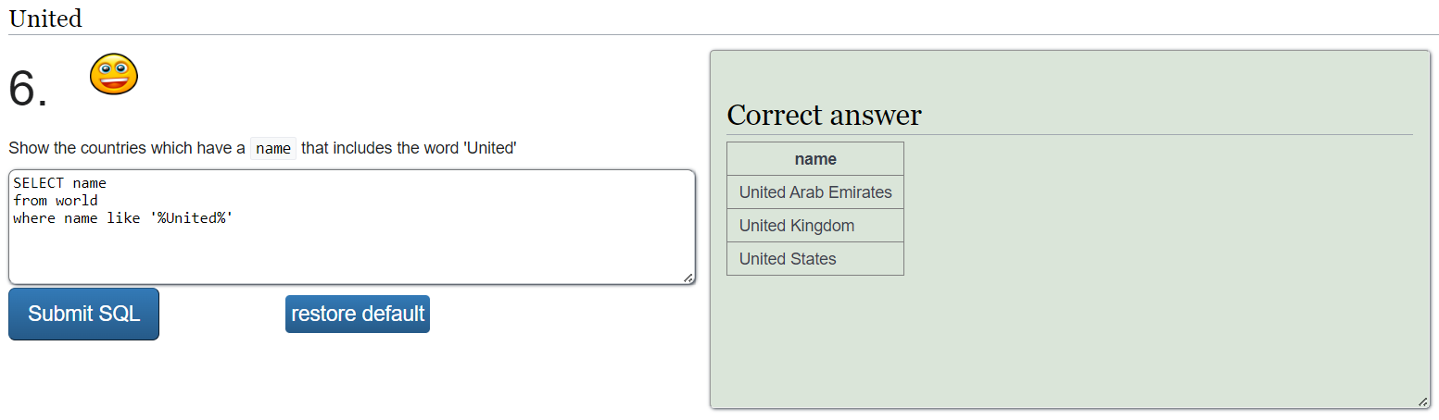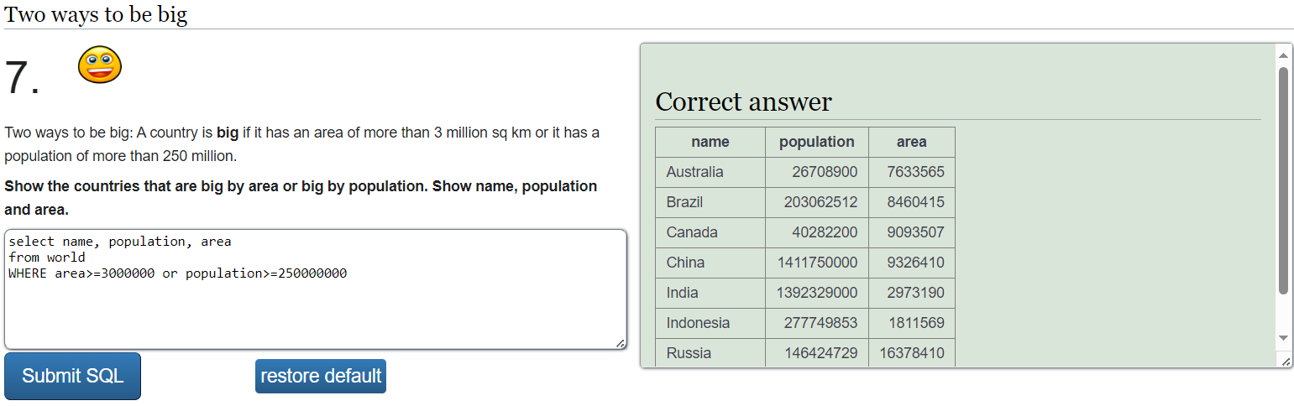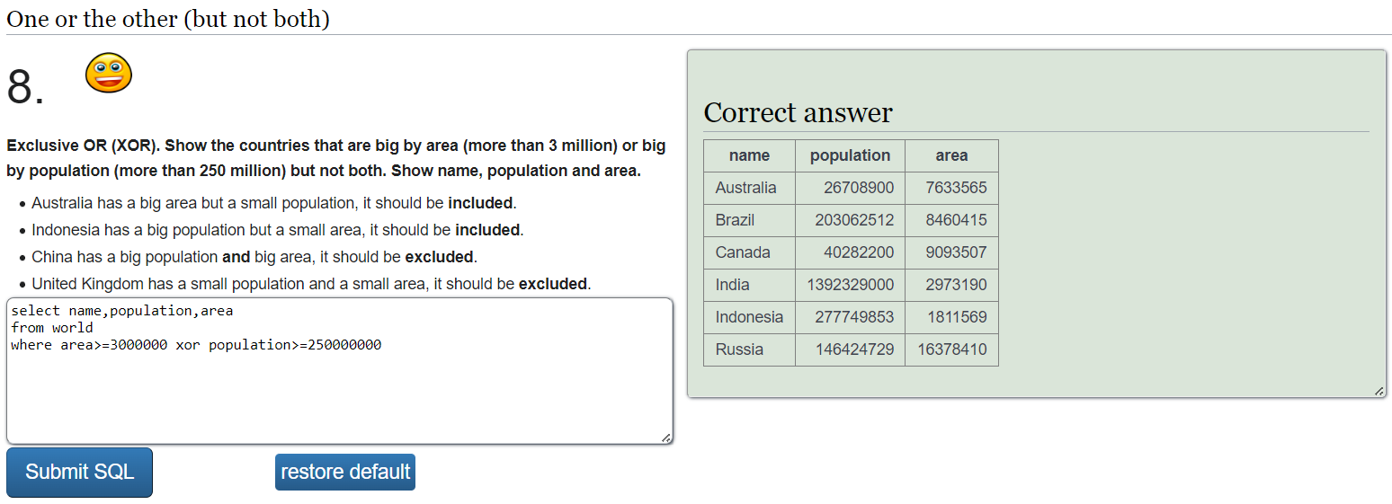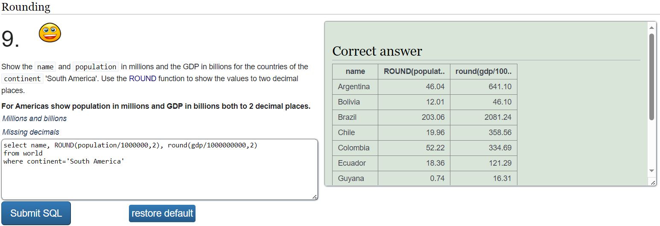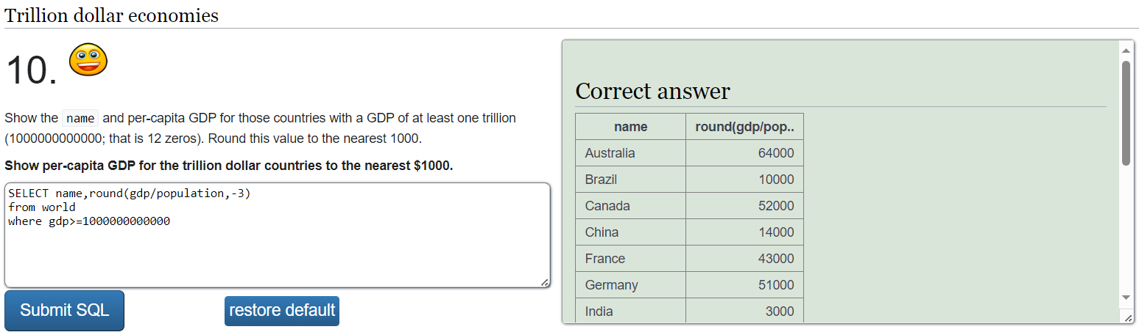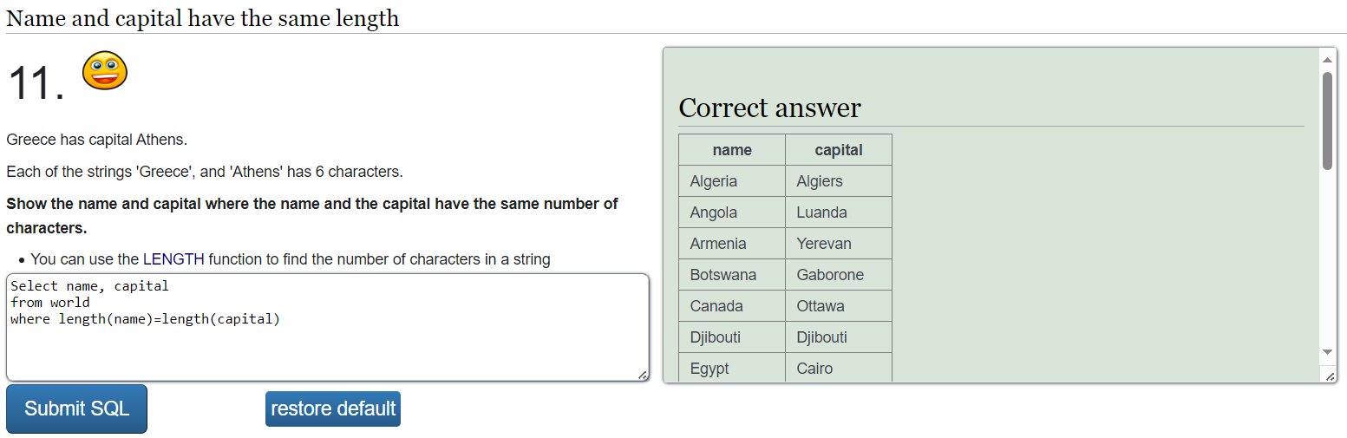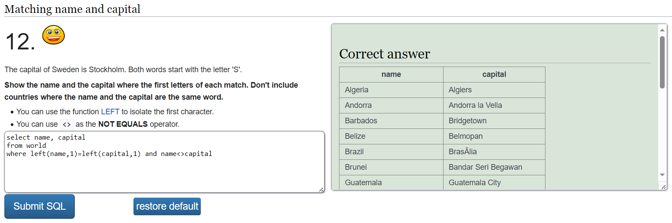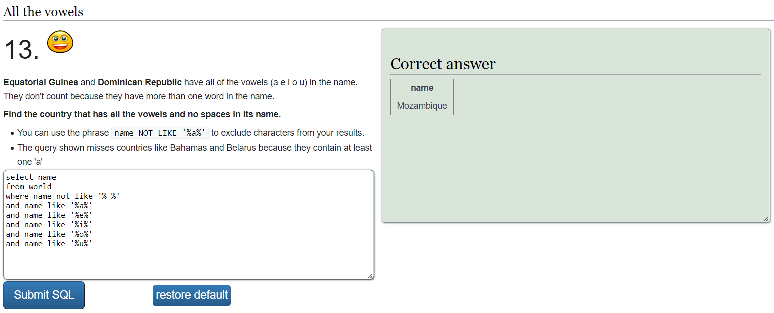

## SELECT from Nobel

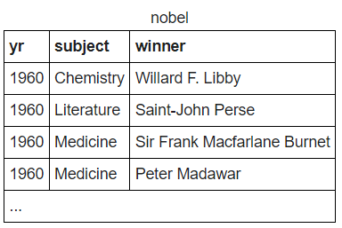

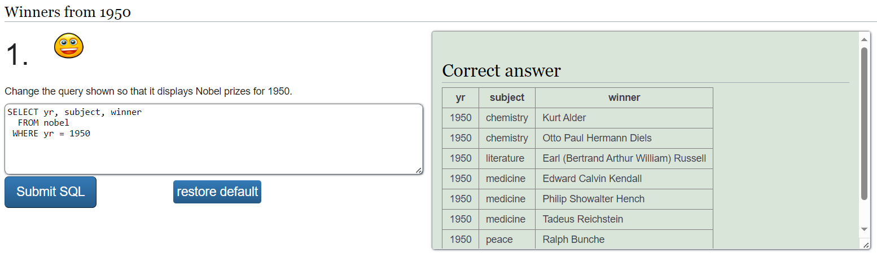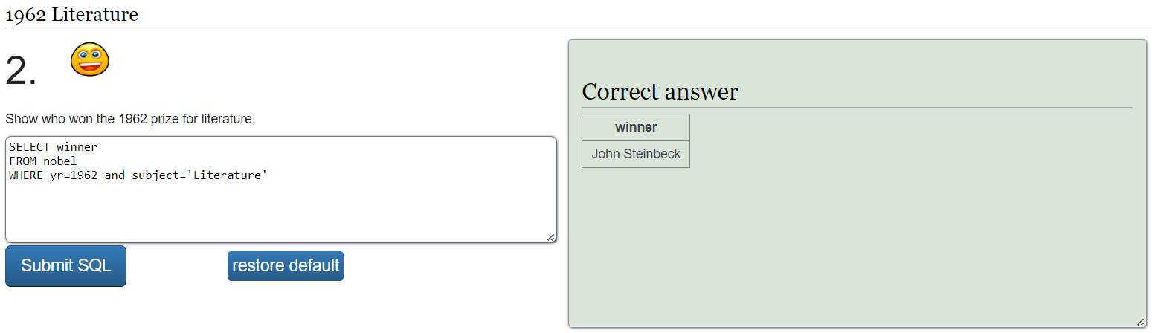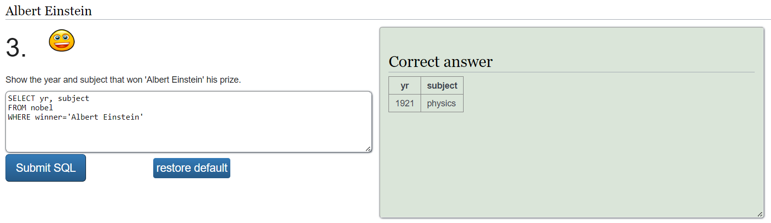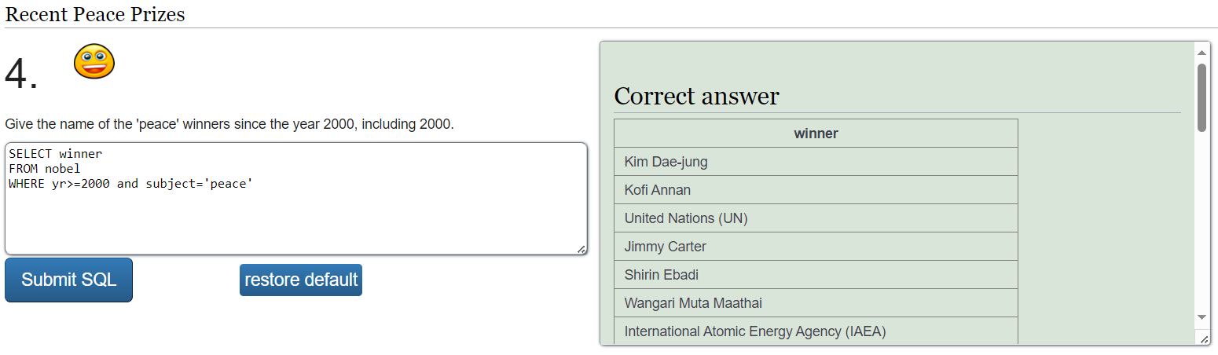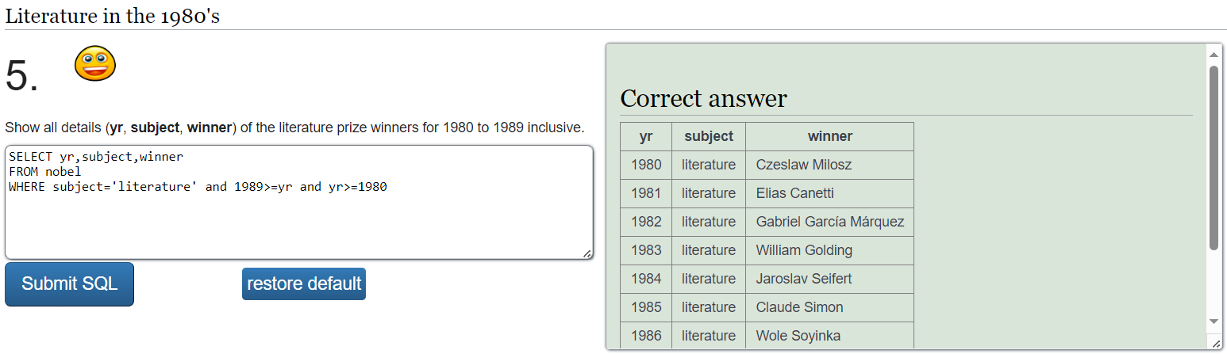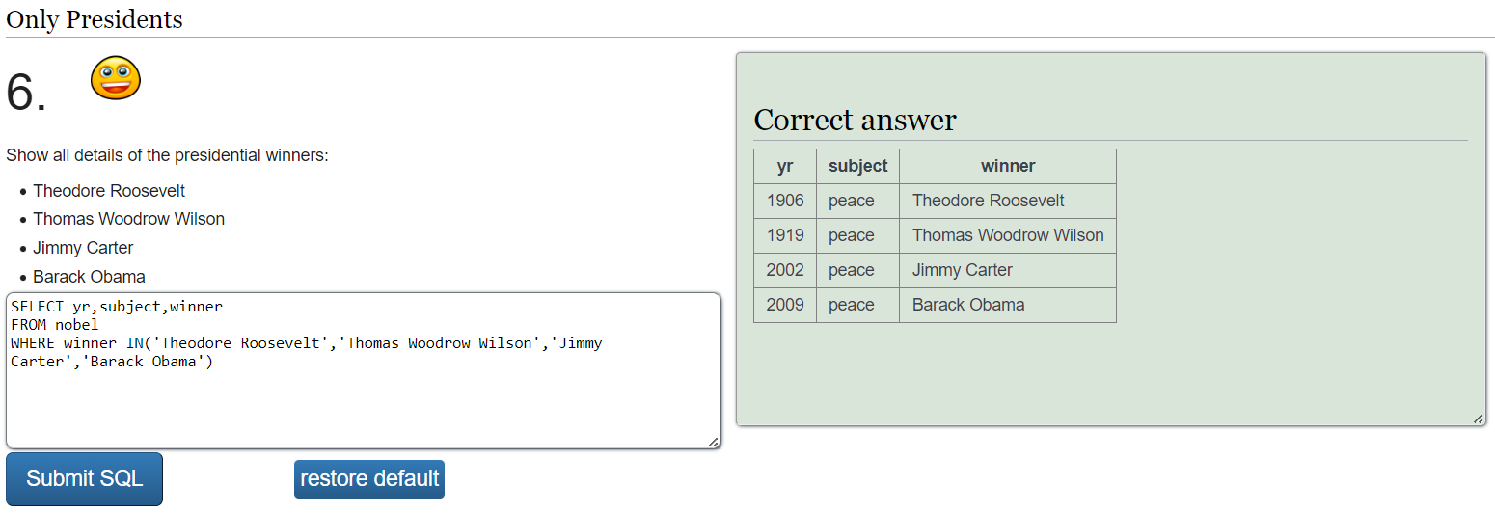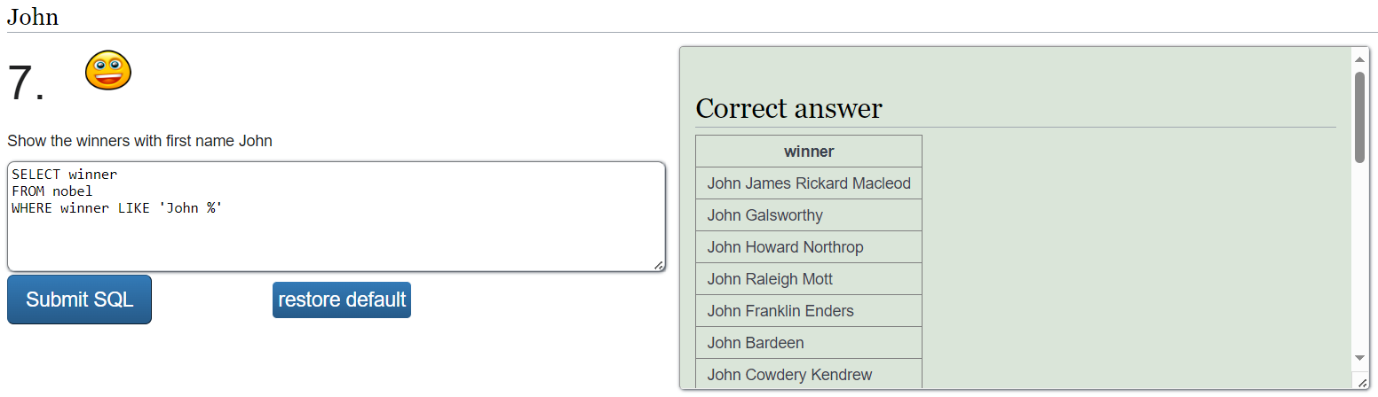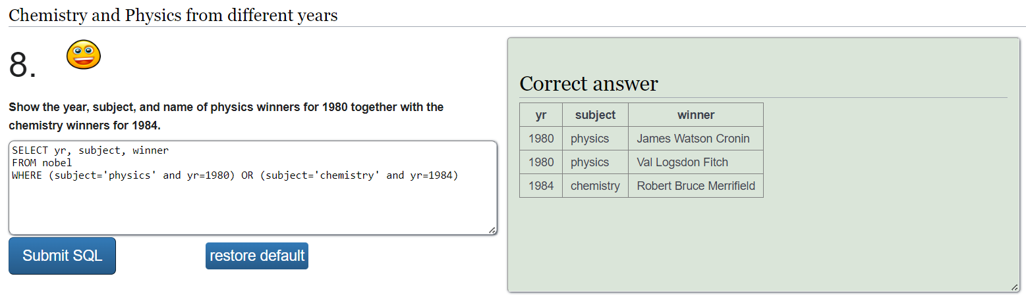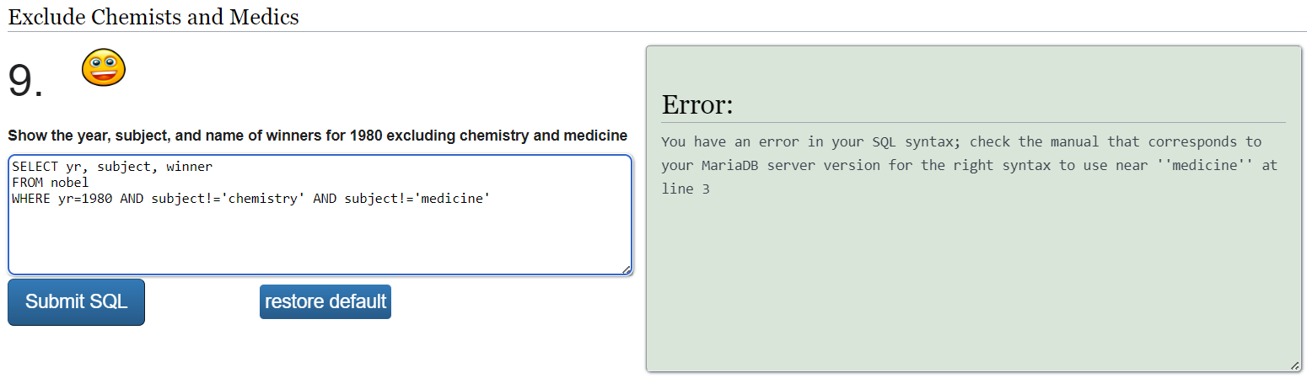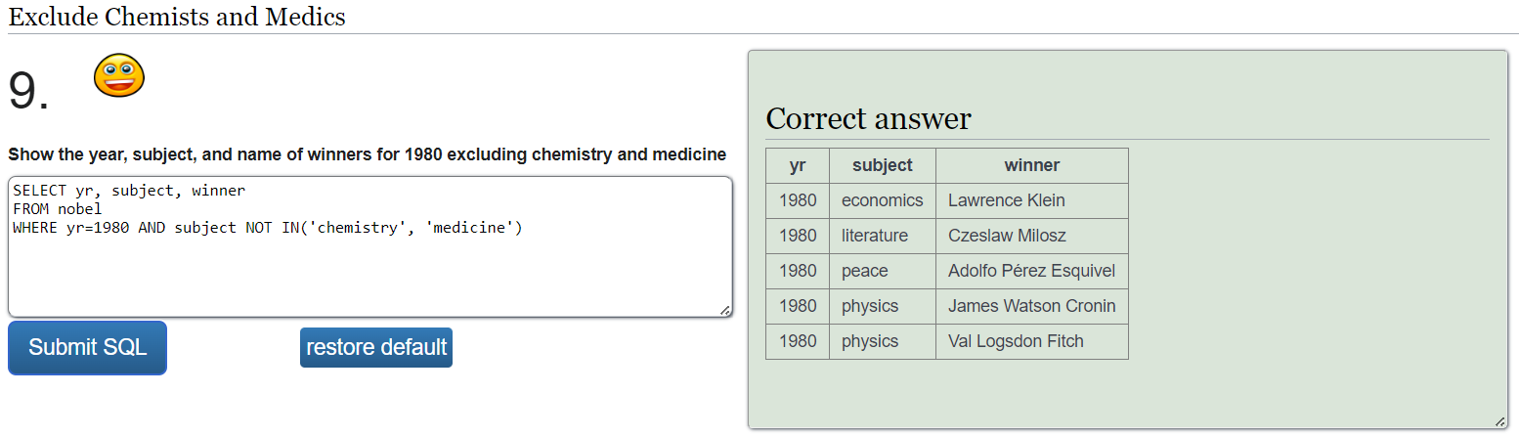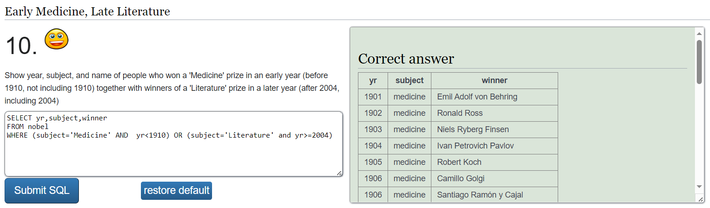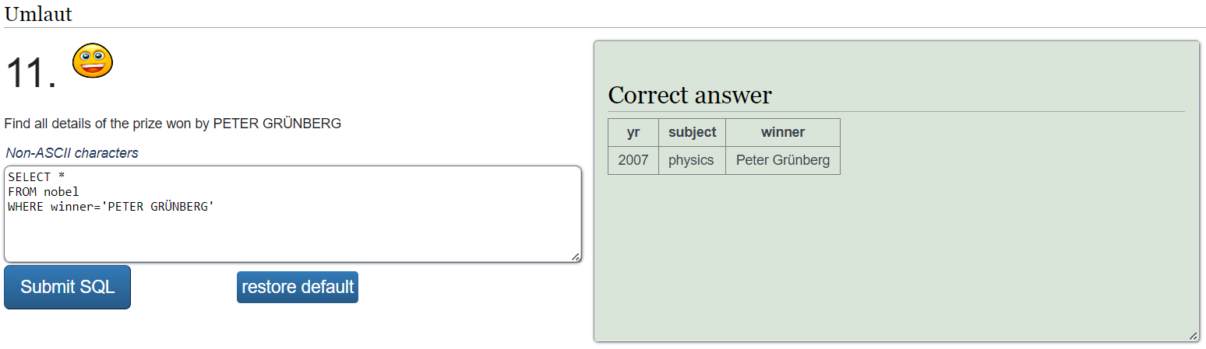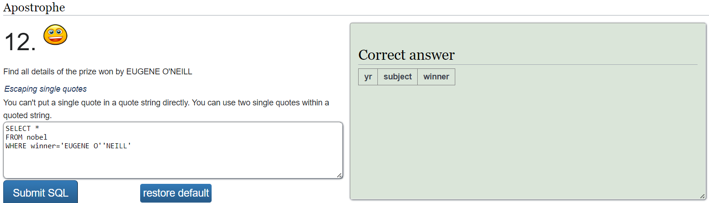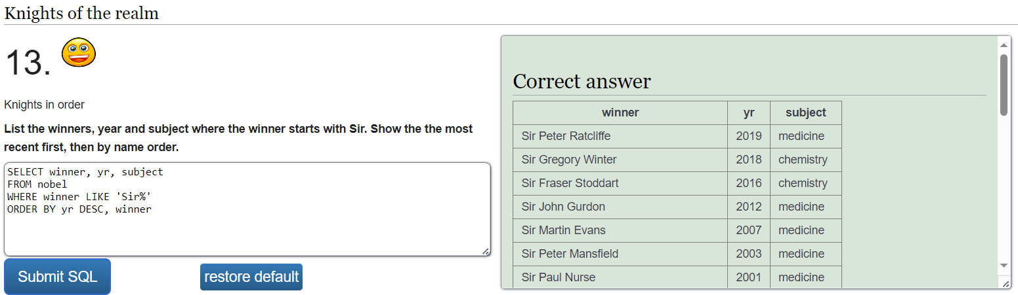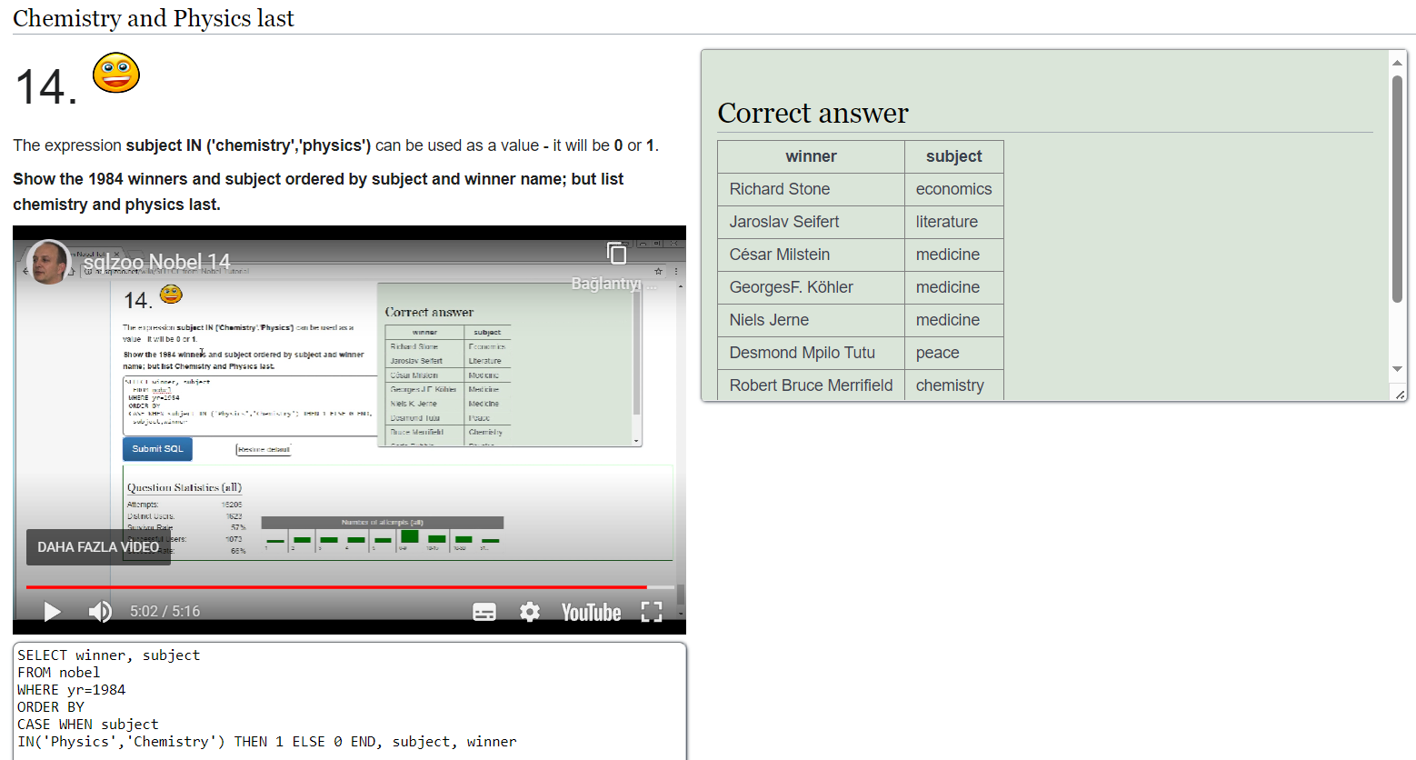

## SELECT within SELECT

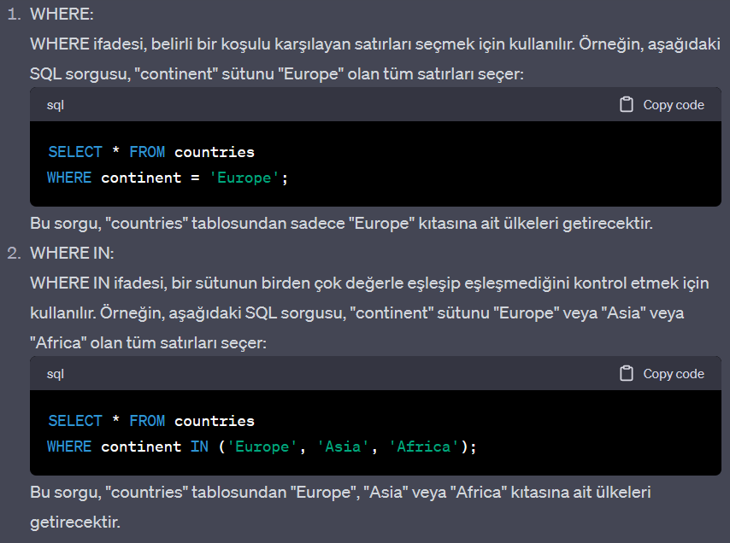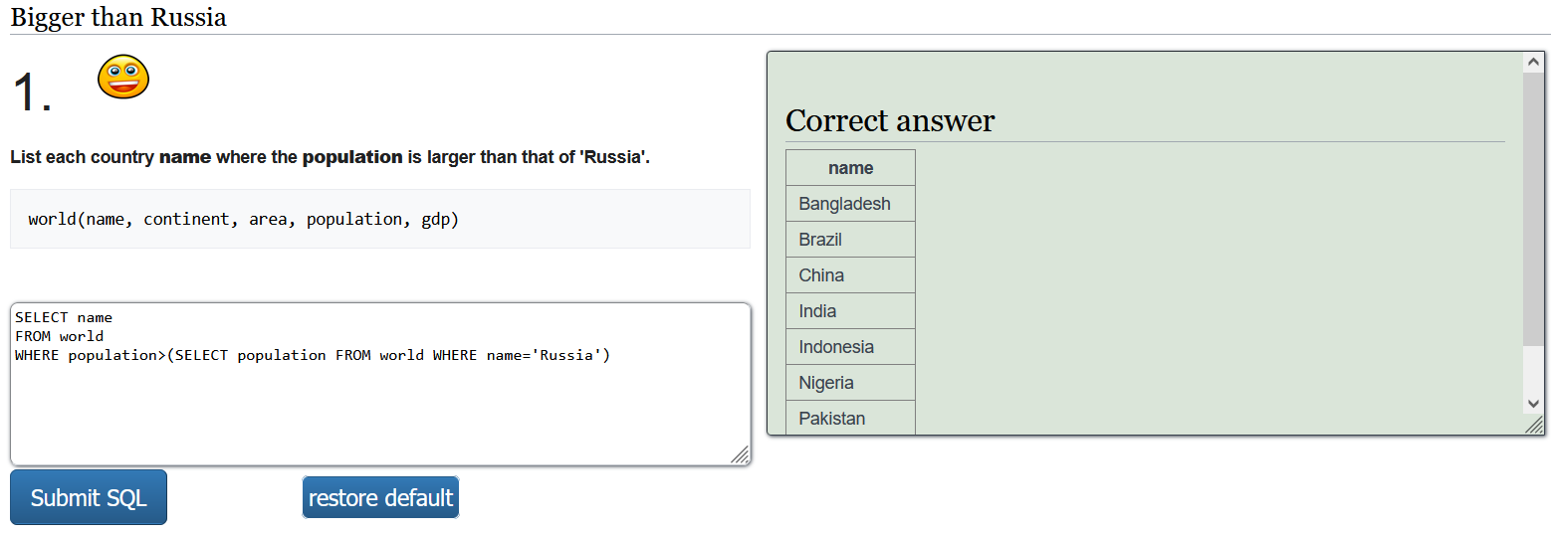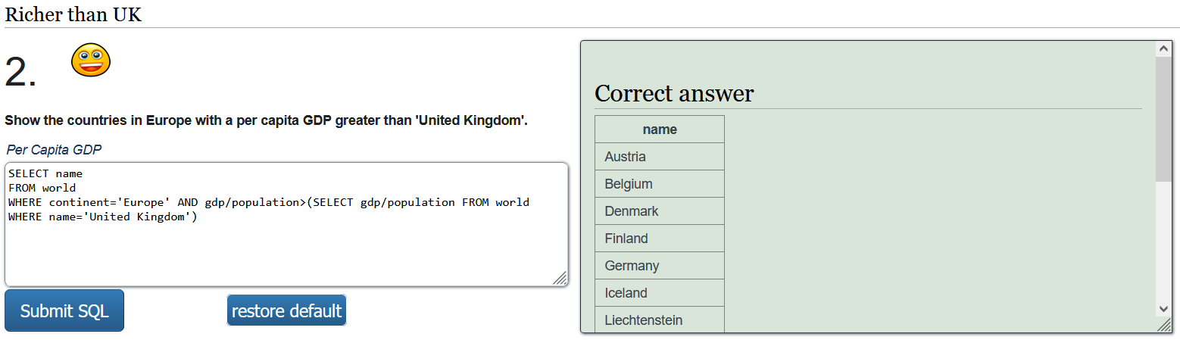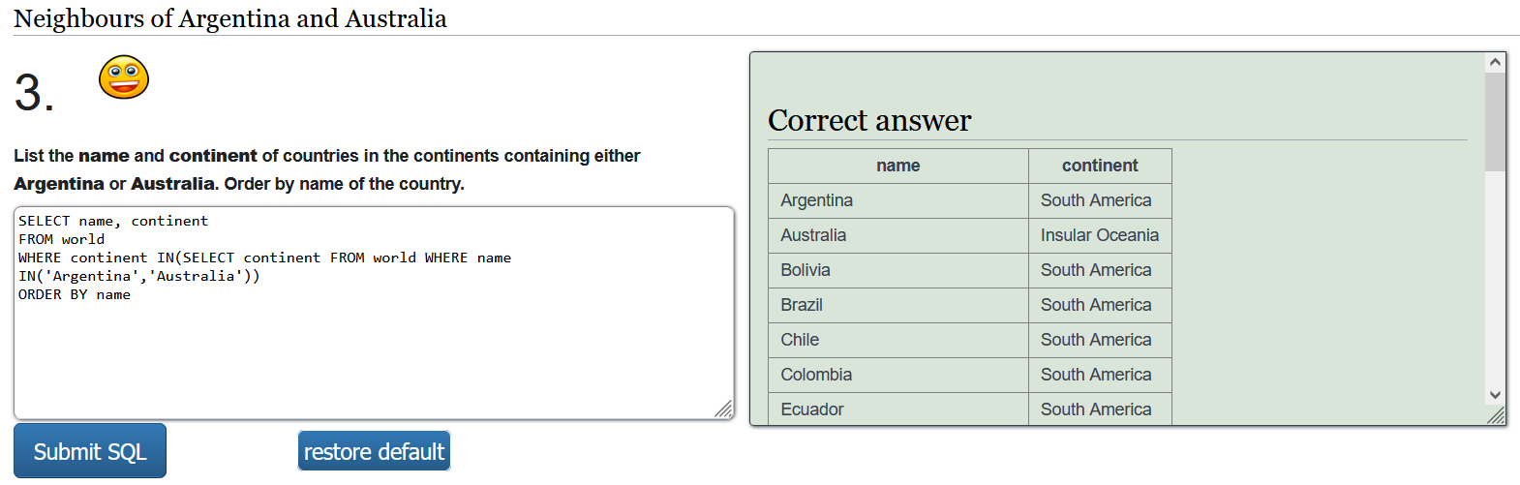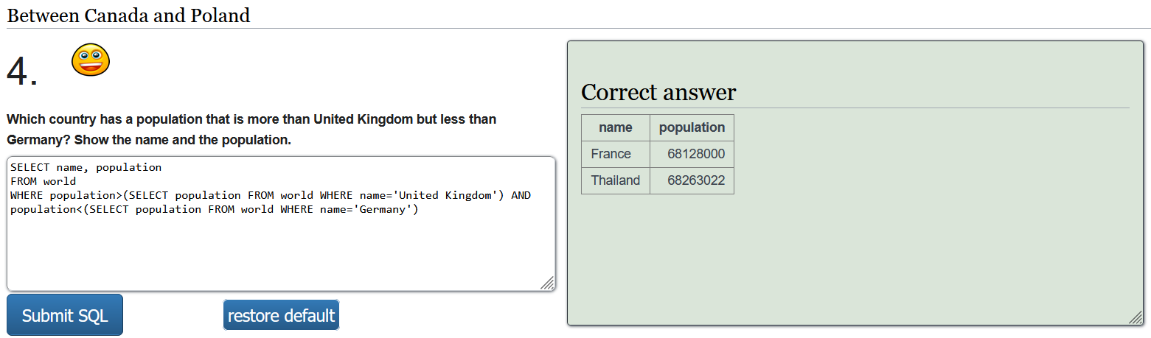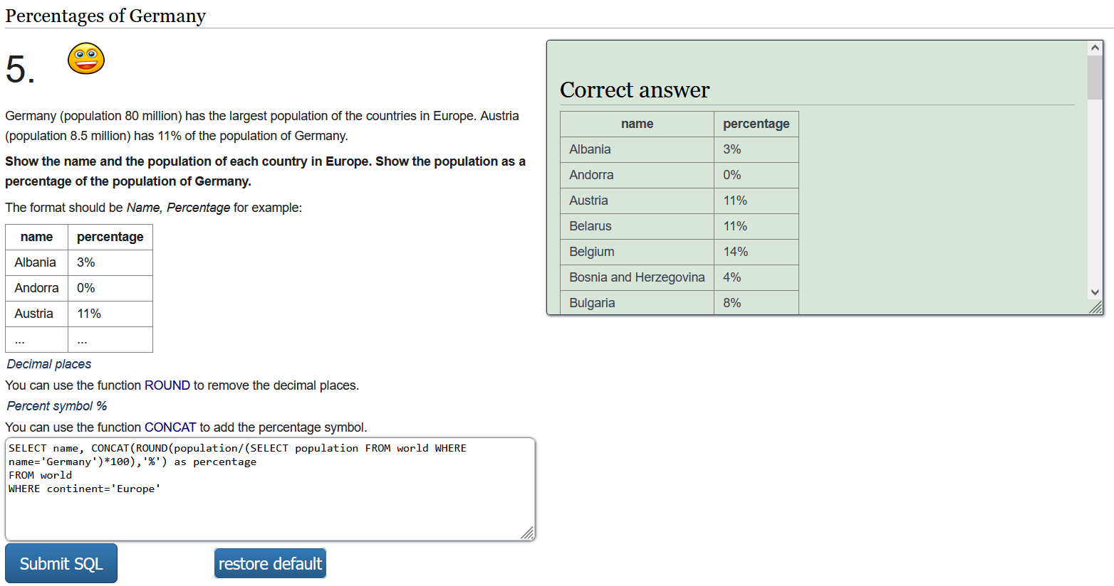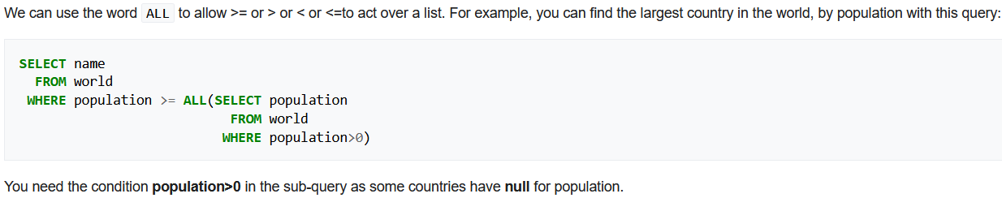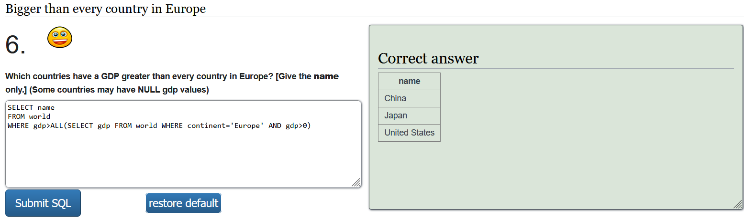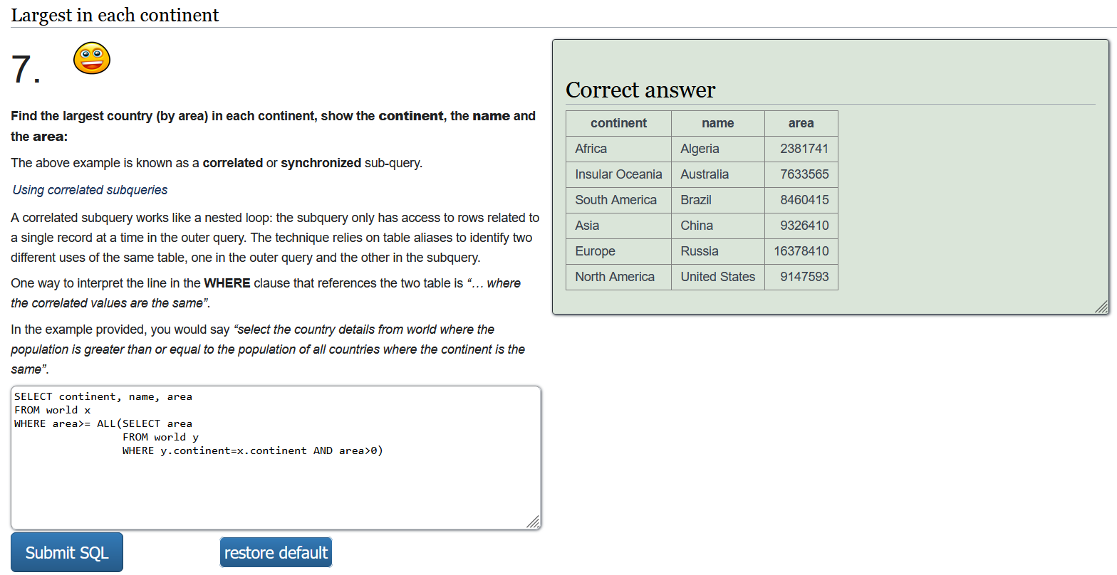

Açıklaması:

* Dıştaki WHERE denklemindeki area’ların kıtasıyla içteki W HERE denklemindeki kıtaların area’sı eşleştirilir.
* Mesela dıştaki Russia-Europe-16378410 satırının alanı tüm Europe satırlarının alanıyla (SELECT’ten area’yı seçtik) karşılaştırılır.
* 3.satırda yazan ilk area bizim aradığımız, ikinci area karşılaştırdığımız arealar

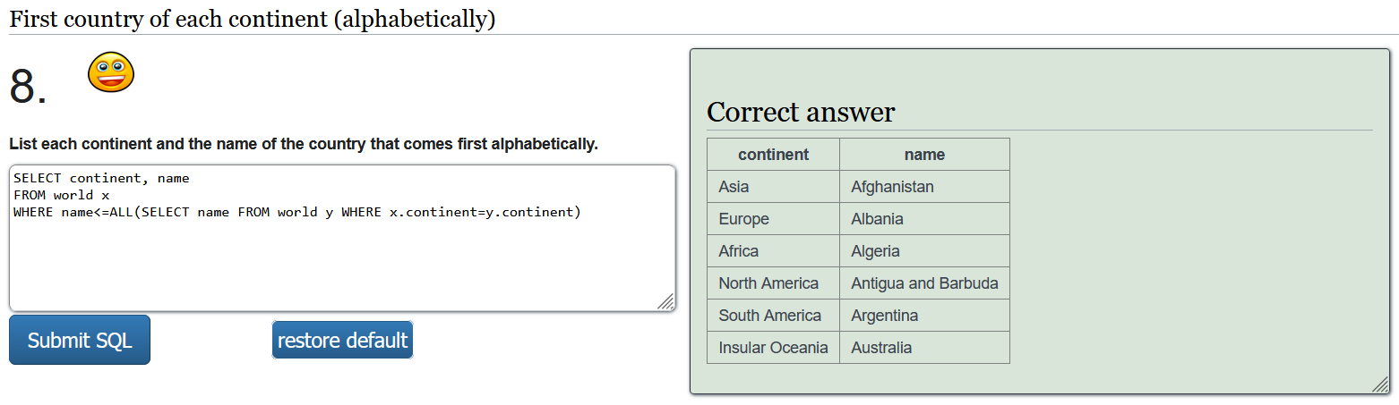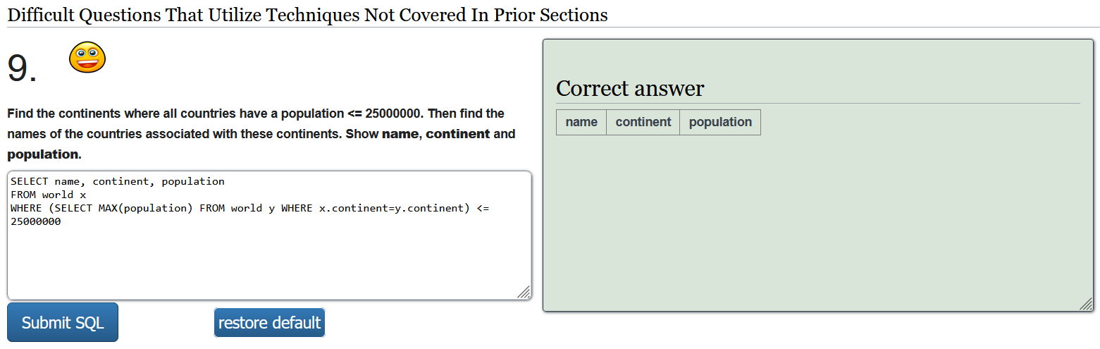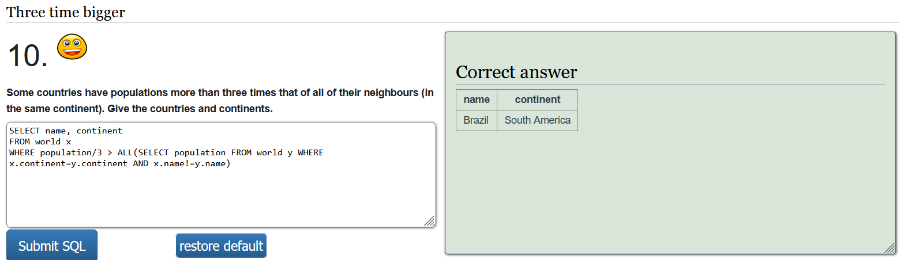

## SUM and COUNT

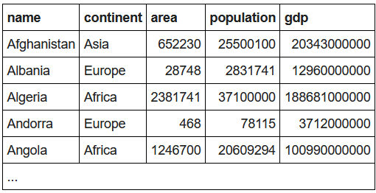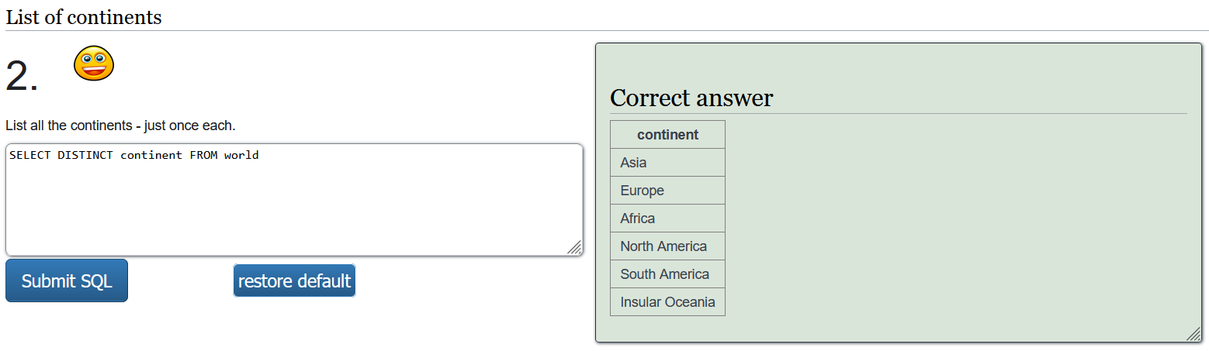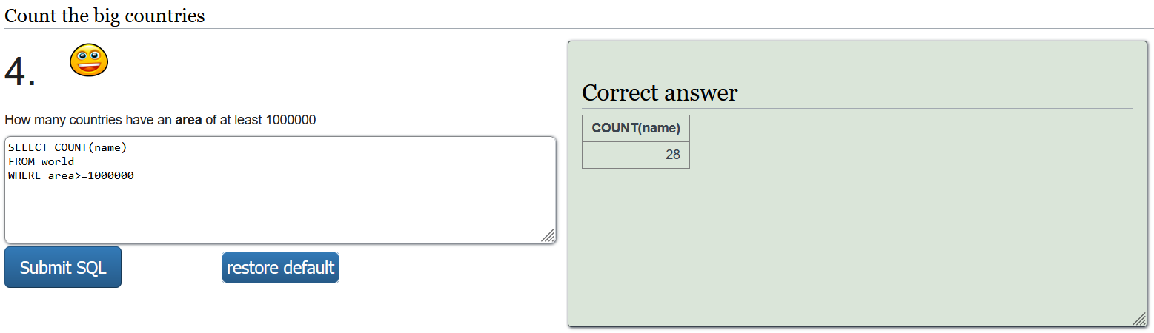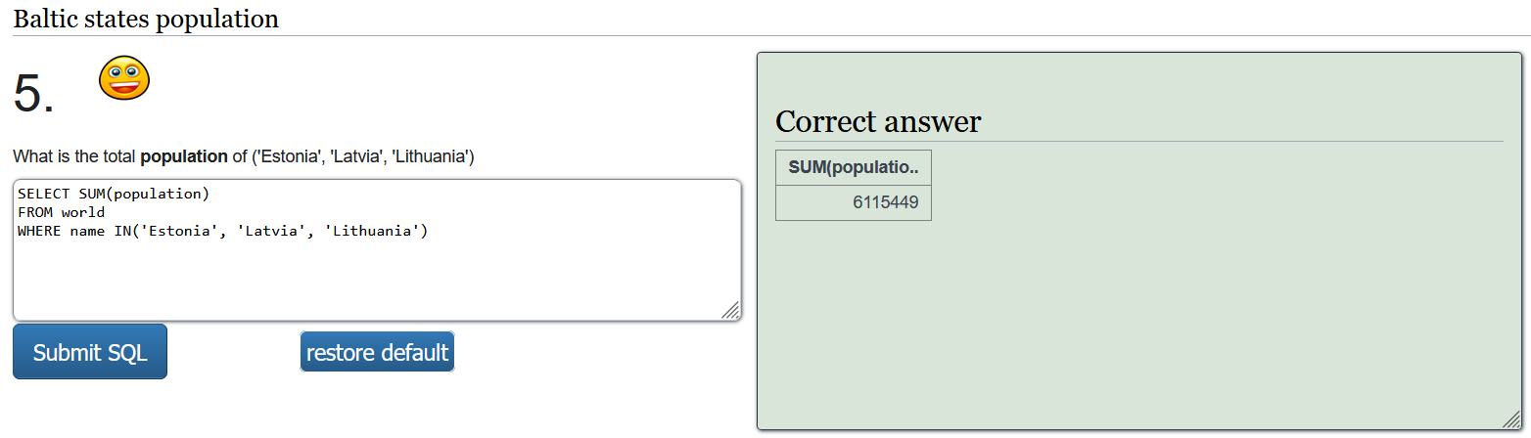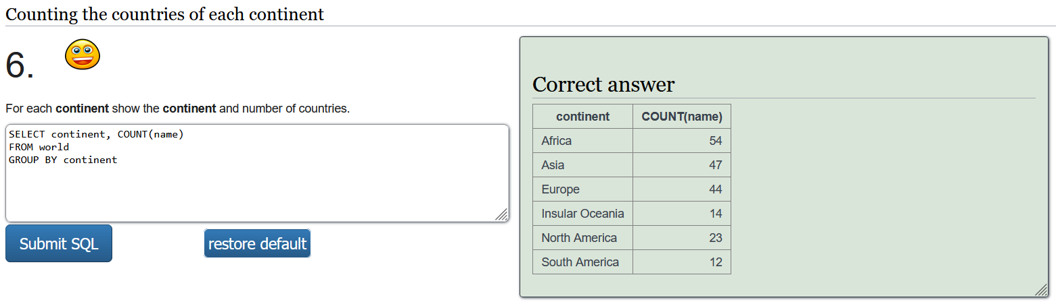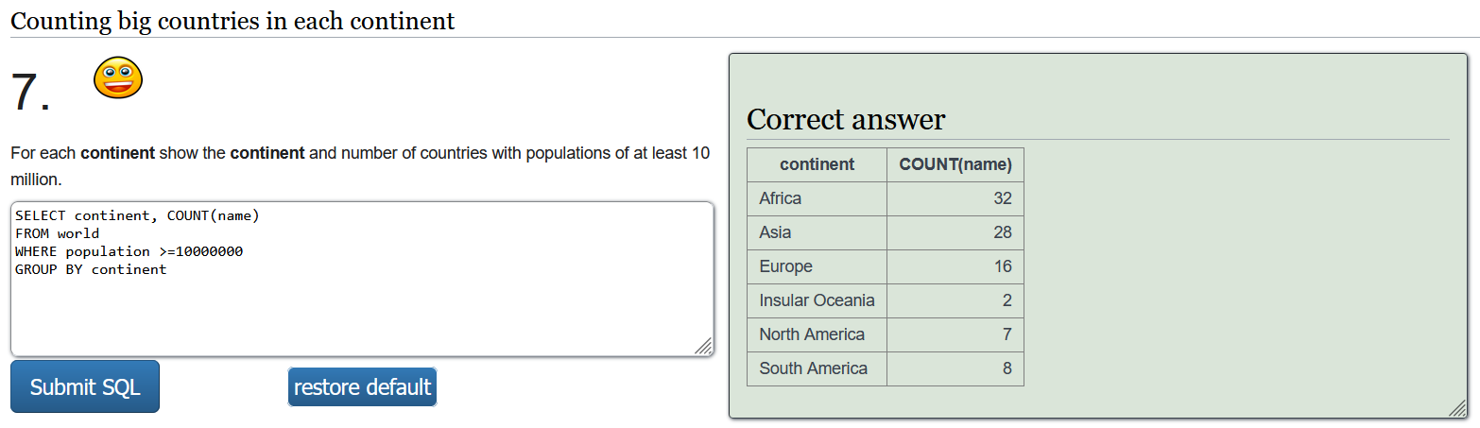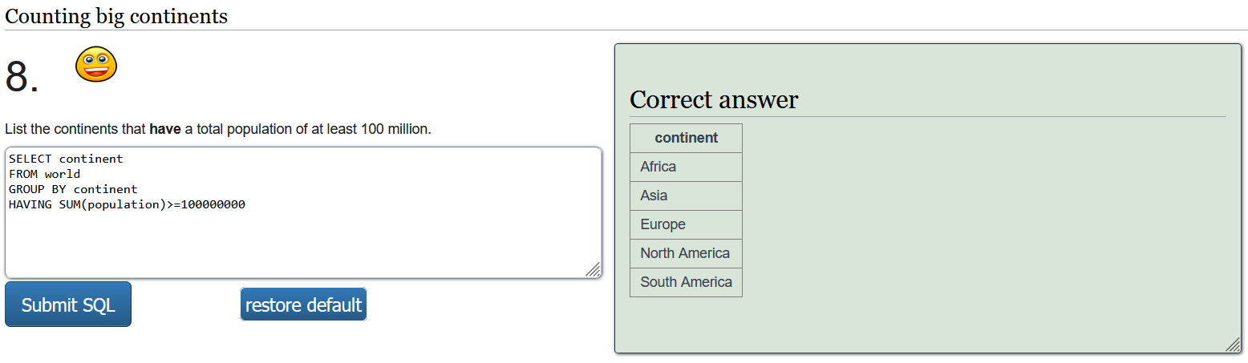

## JOIN

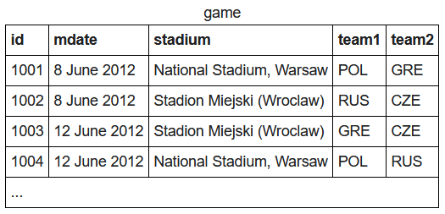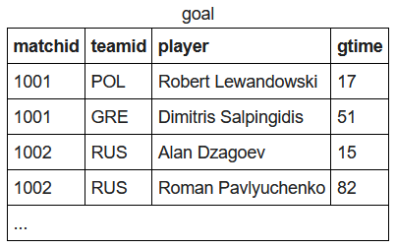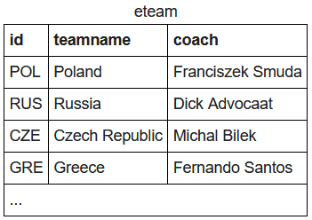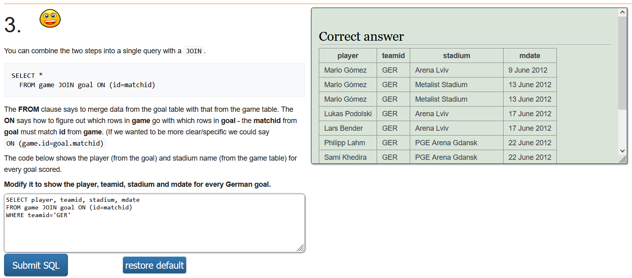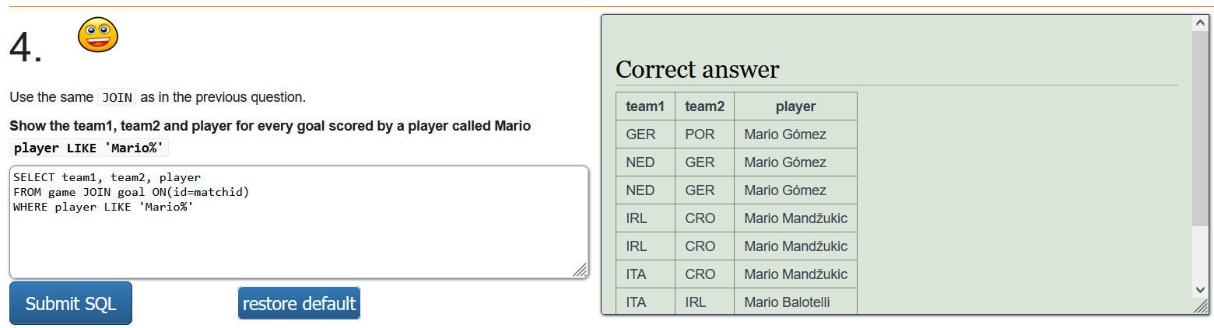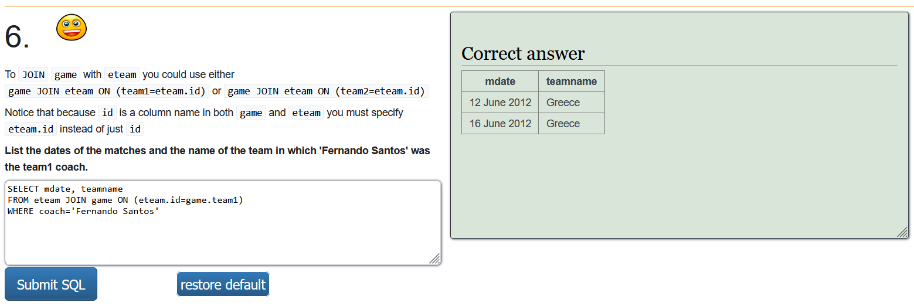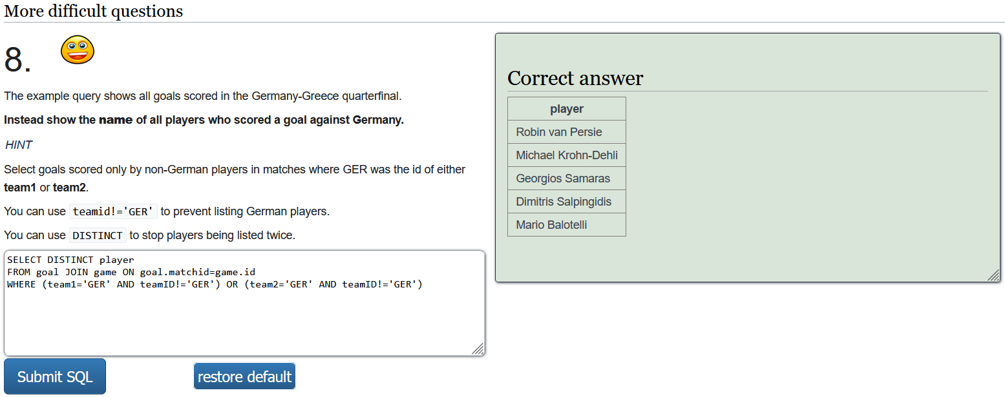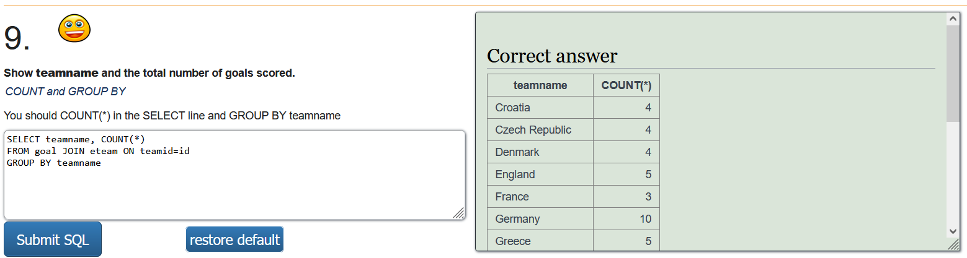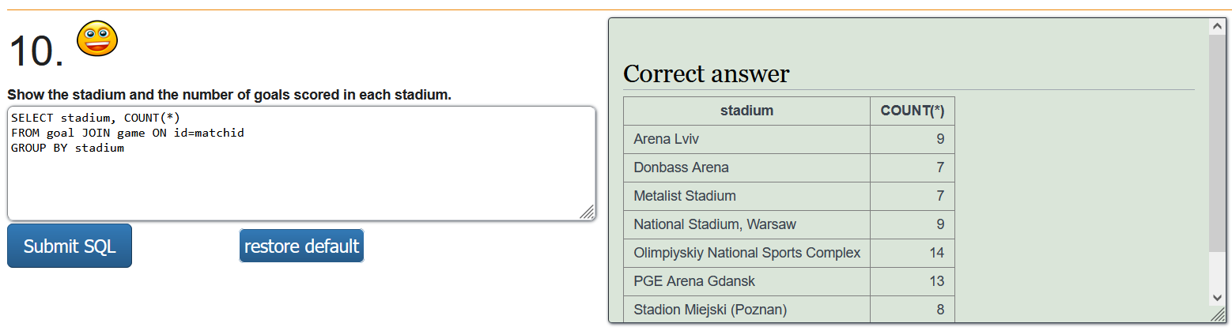

COUNT(*) sütun sayısını sayıyor. İçine ne koyduğunun önemi yok. * koyarsan daha hızlı çalışır.

FROM game JOIN goal ON matchid = id 🡪 sadece match eden sütunları alıyor.

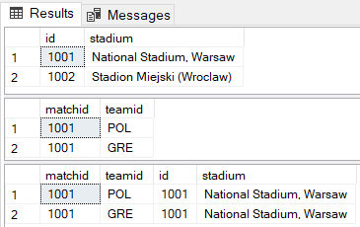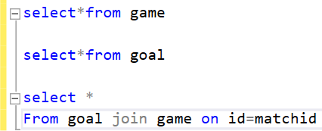

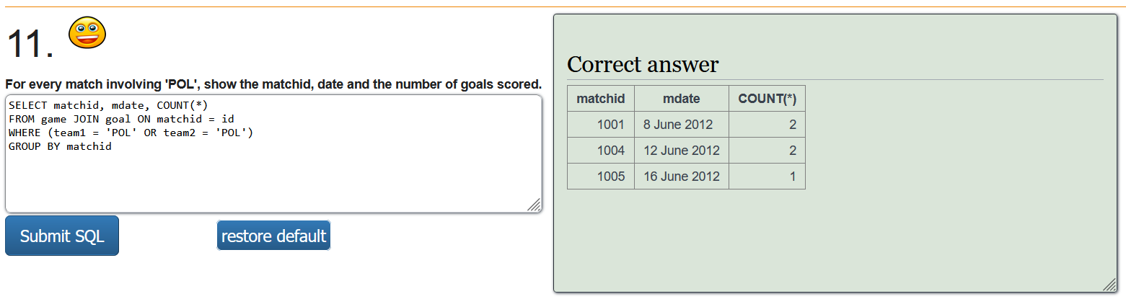 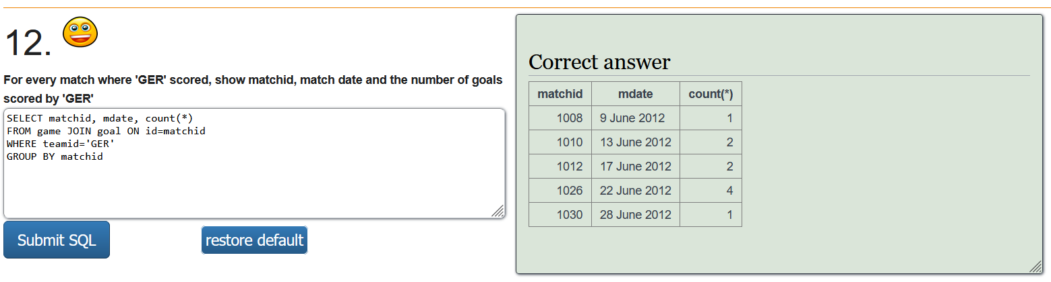

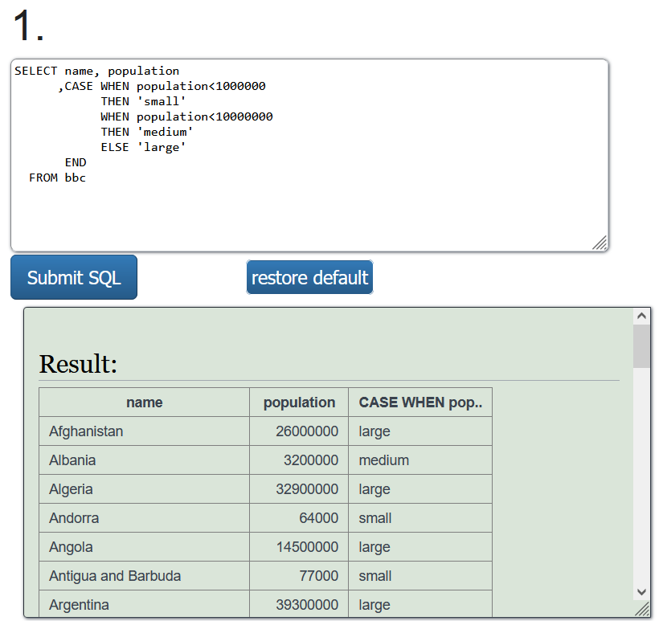 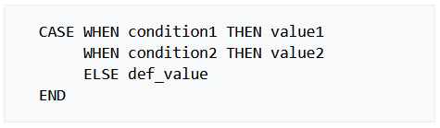

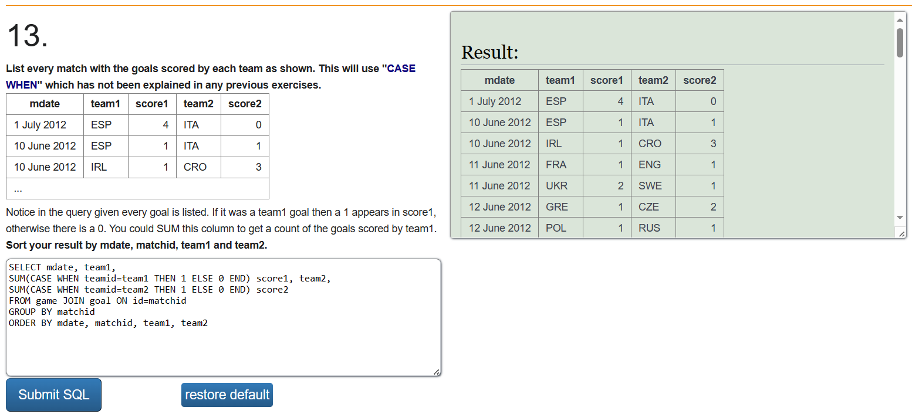

## More JOIN

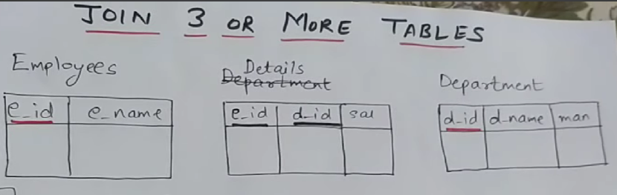 join=inner join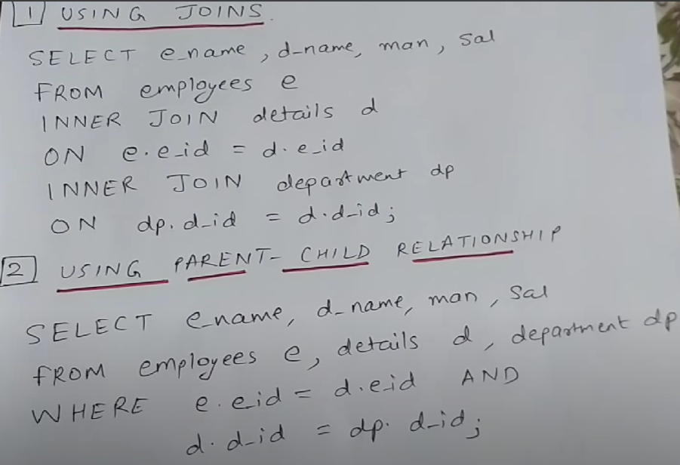



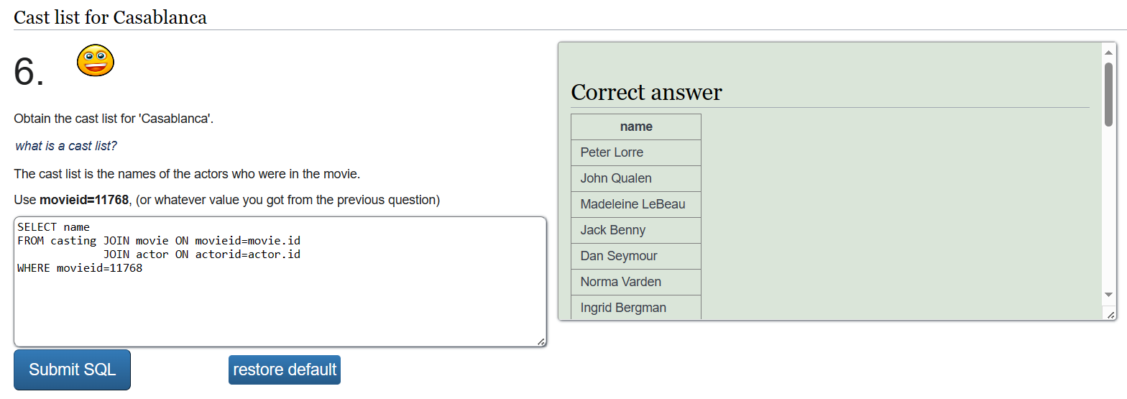 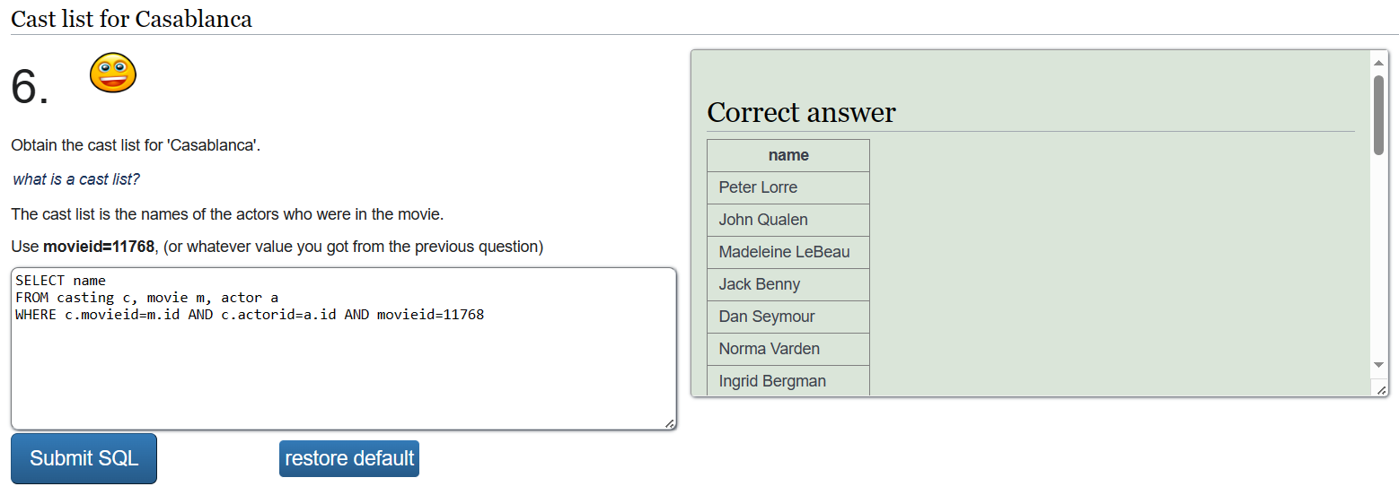 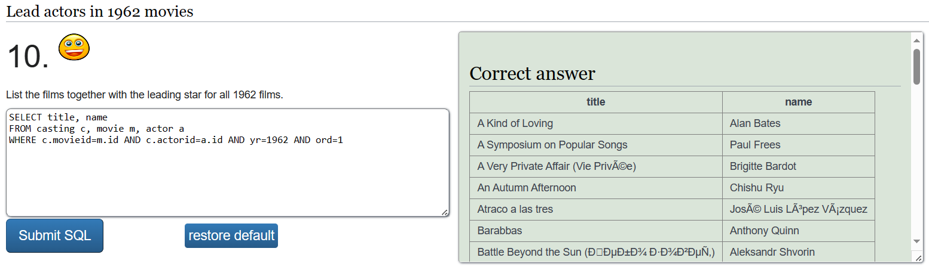 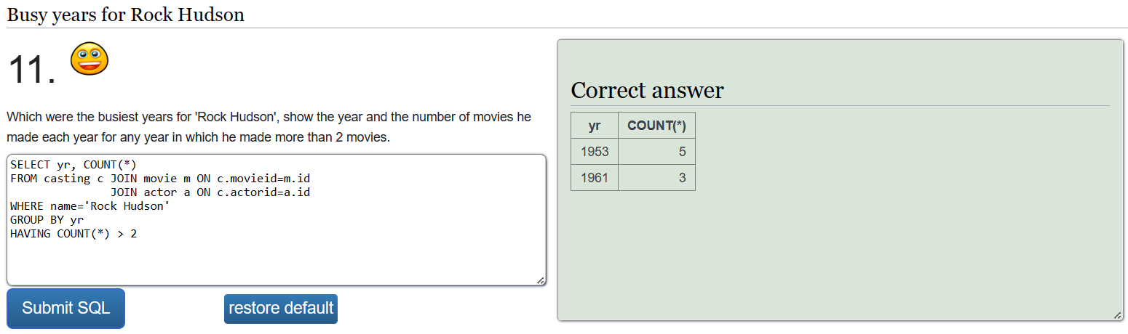 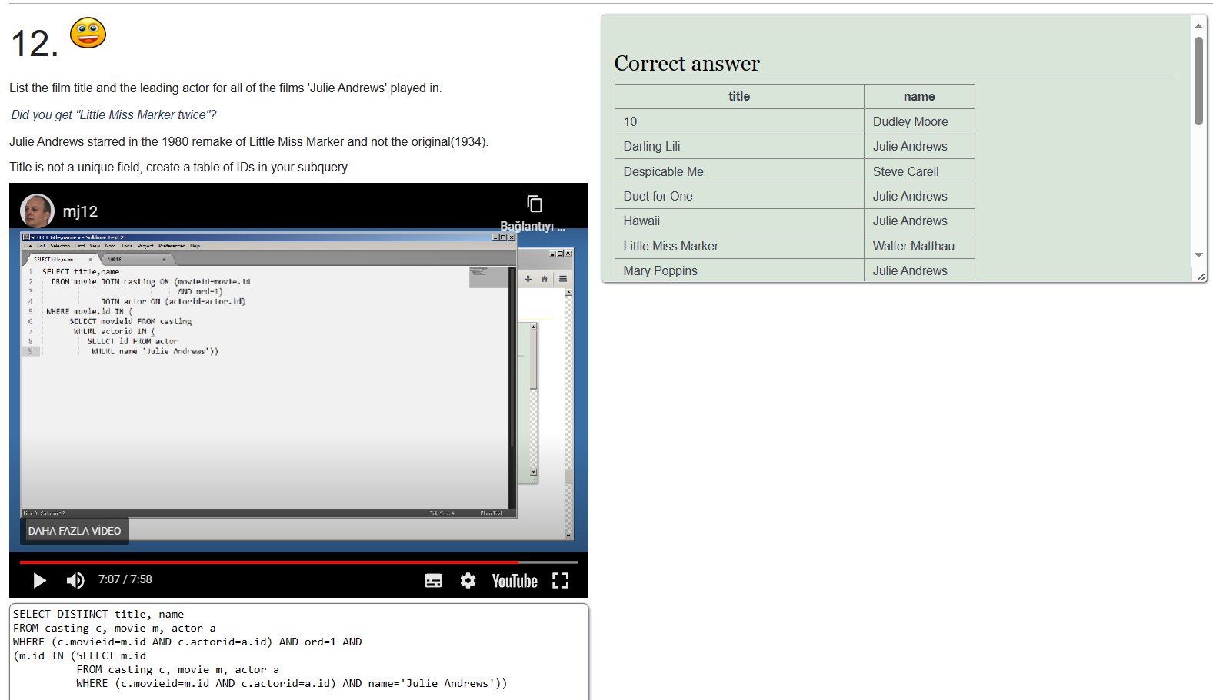

Hatalı:  Doğru: 

Code:

SELECT DISTINCT title, name

FROM casting c, movie m, actor a

WHERE (c.movieid=m.id AND c.actorid=a.id) AND ord=1 AND

(m.id IN (SELECT m.id

FROM casting c, movie m, actor a

WHERE (c.movieid=m.id AND c.actorid=a.id) AND name='Julie Andrews'))

Alternative: 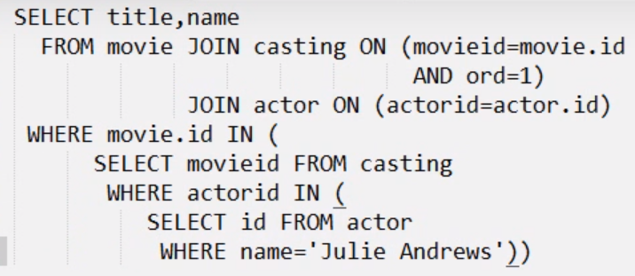

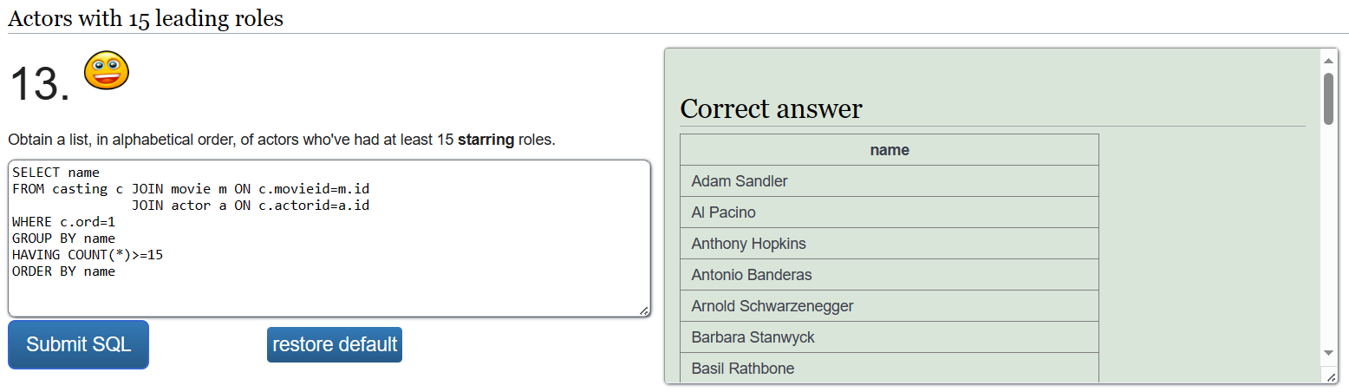

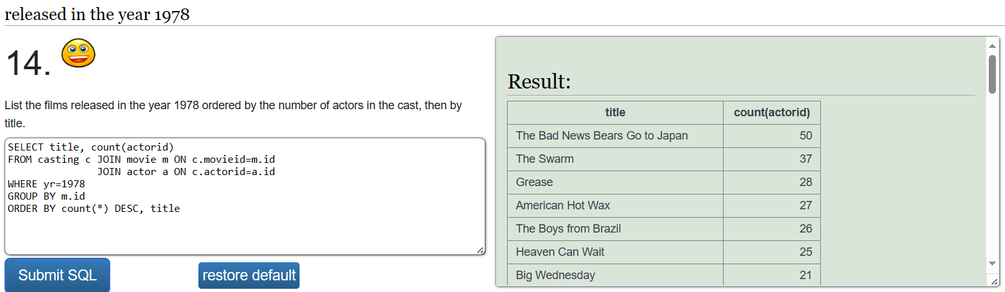 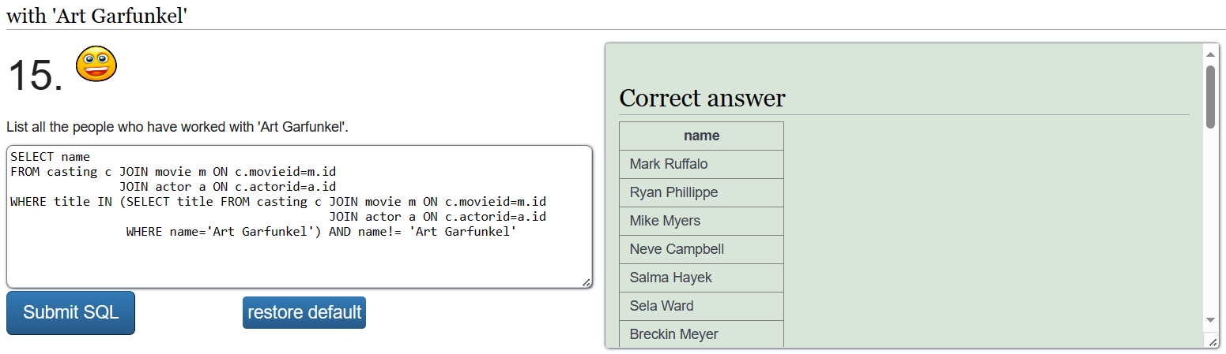

## Using Null

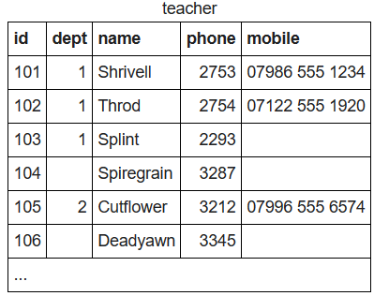 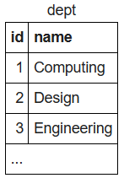

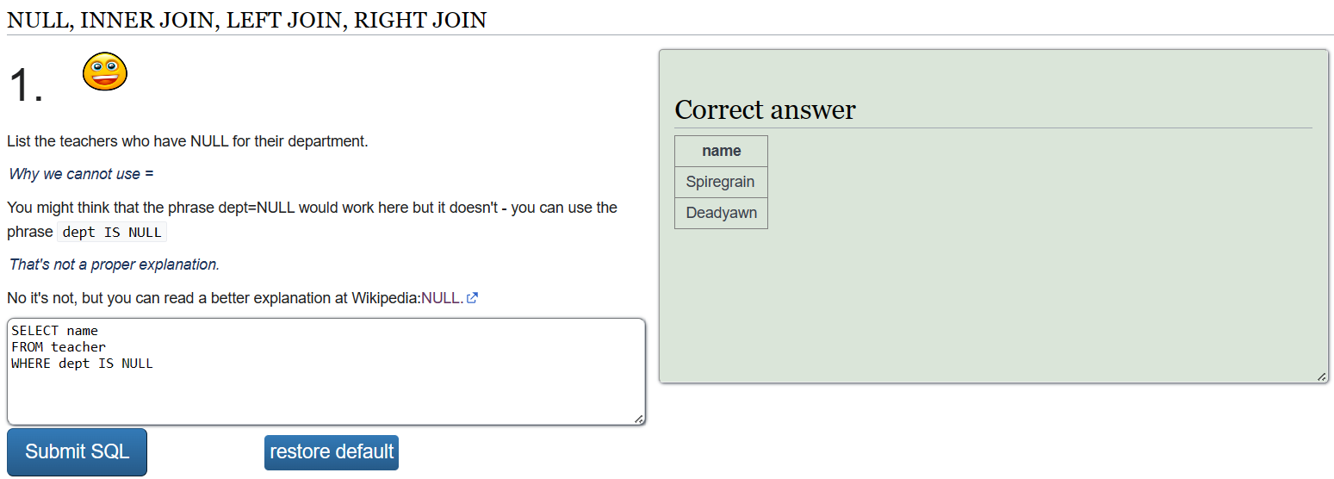 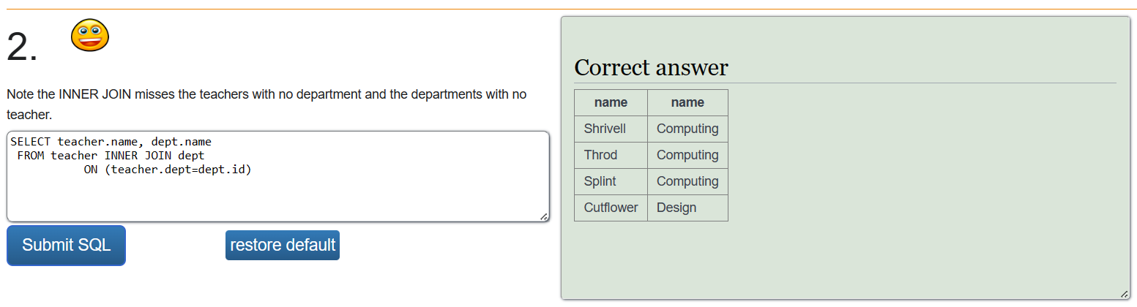

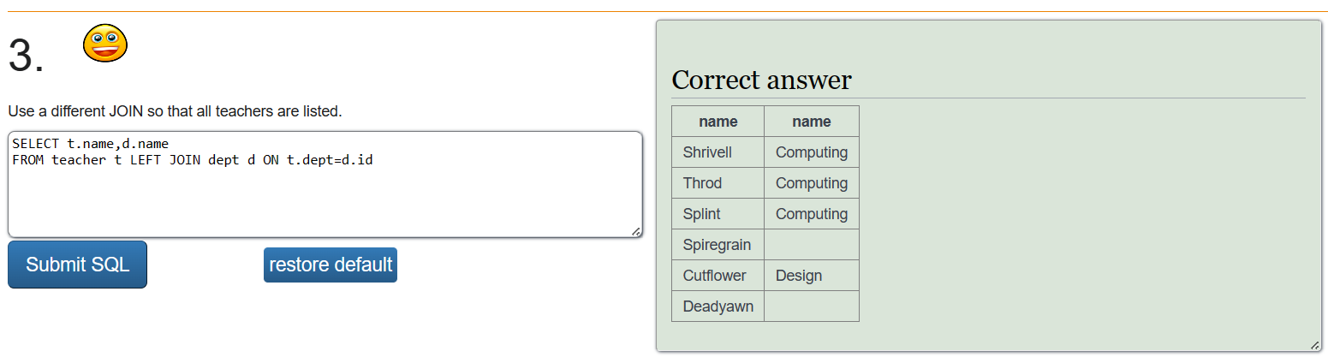

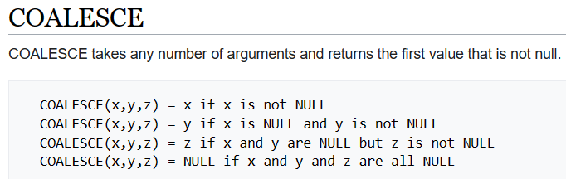

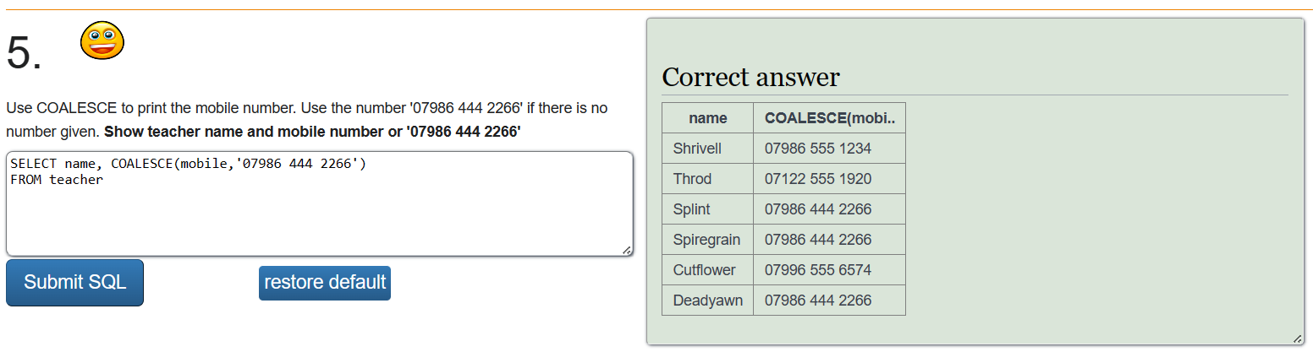 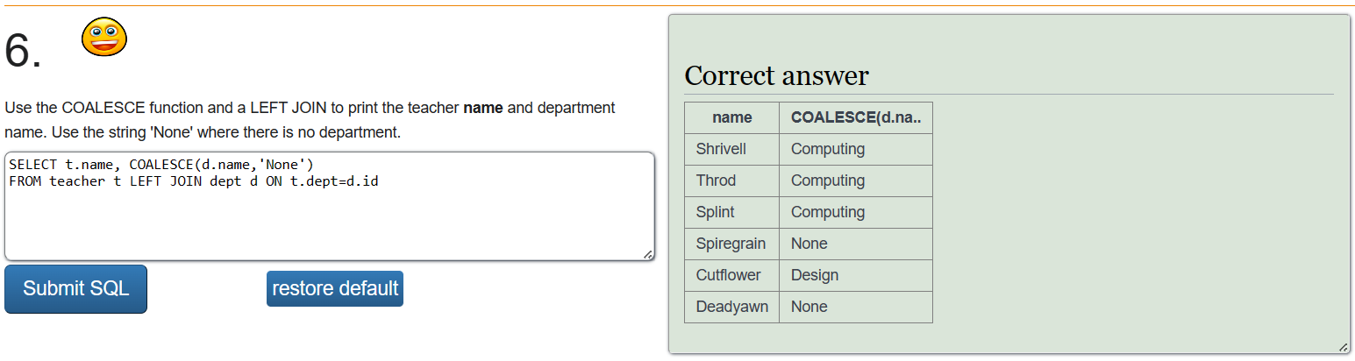 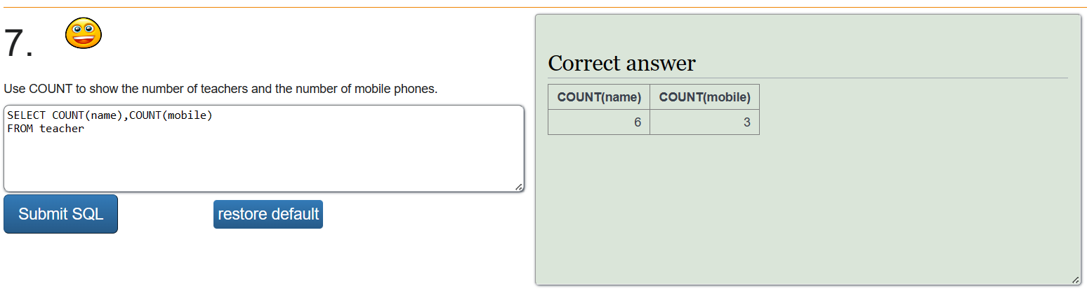 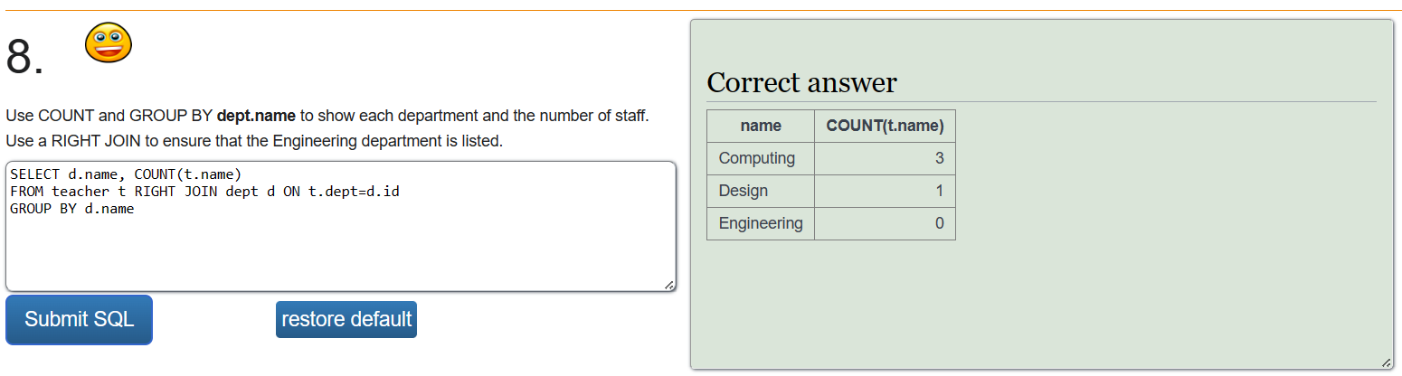 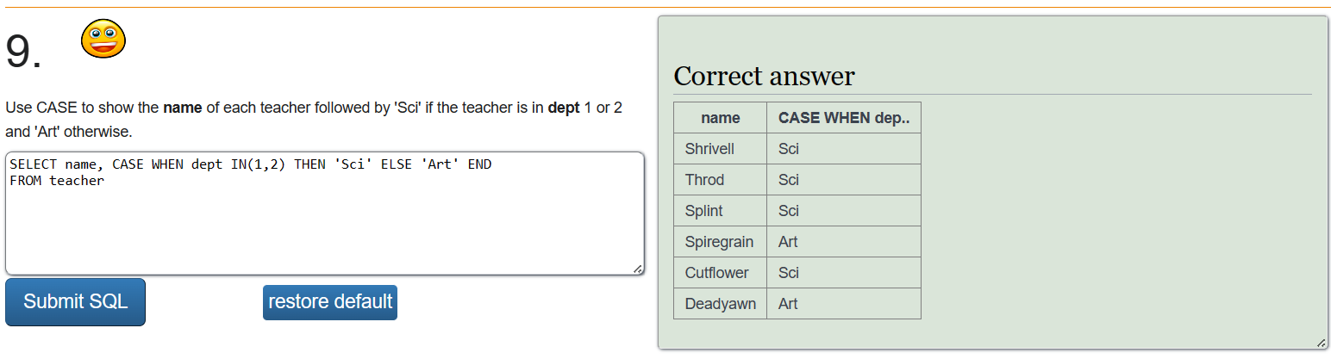 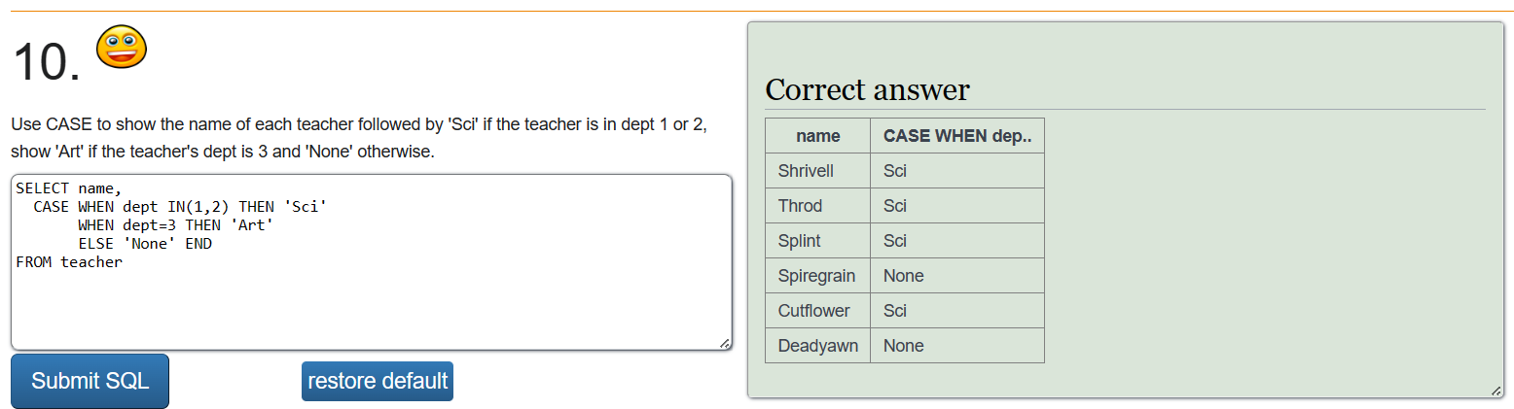

## Self Join

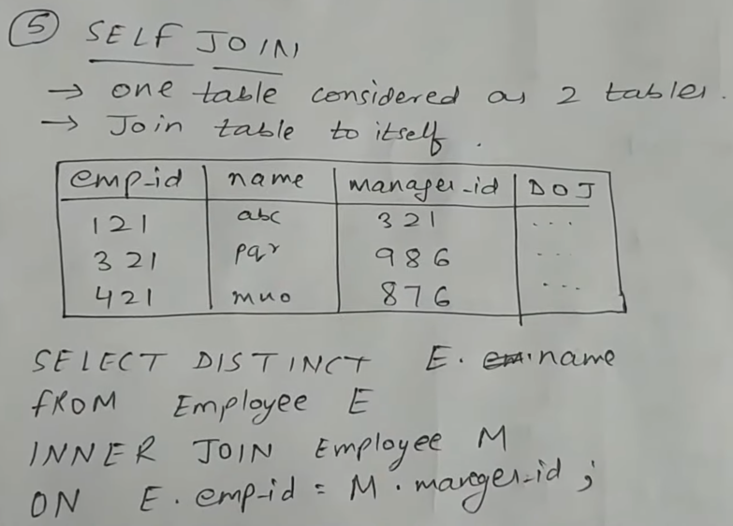 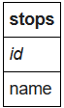 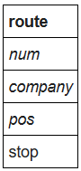

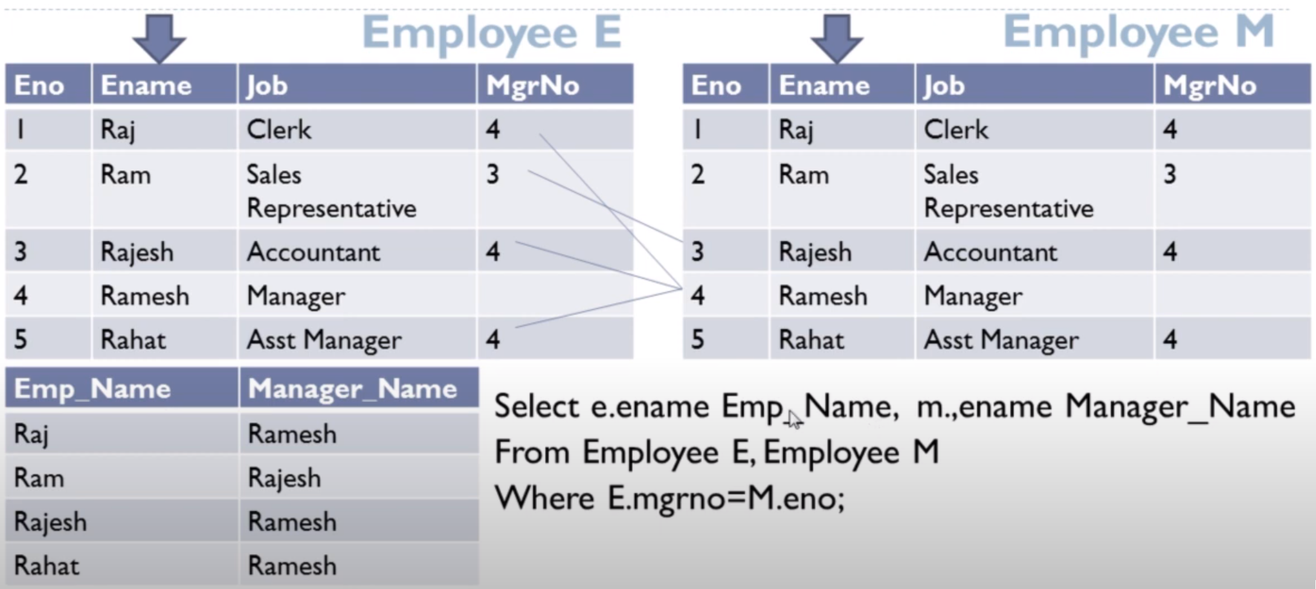

|  |  |  |  |  |
| --- | --- | --- | --- | --- |
|  |  |  | Eno(mgr) | Ename(mgr) |
| Eno | Ename | Job | MgrNo |  |
| 1 | Raj | dasds | 4 | Ramesh |
| 2 | Ram | sdas | 3 | Rajesh |
| 3 | Rajesh | dad | 4 | Ramesh |
| 4 | Ramesh | asdsa |  |  |
| 5 | Rahat | dasds | 4 | Ramesh |

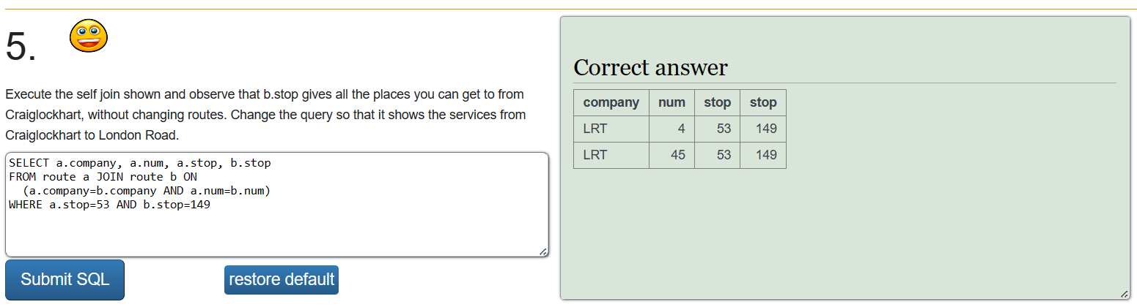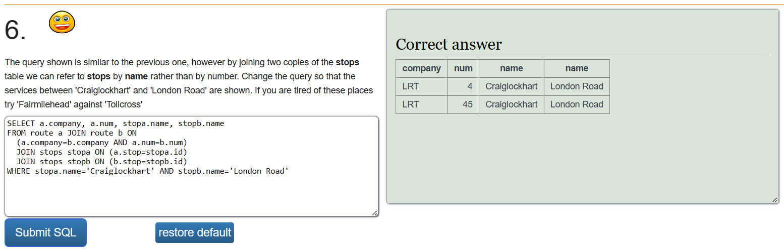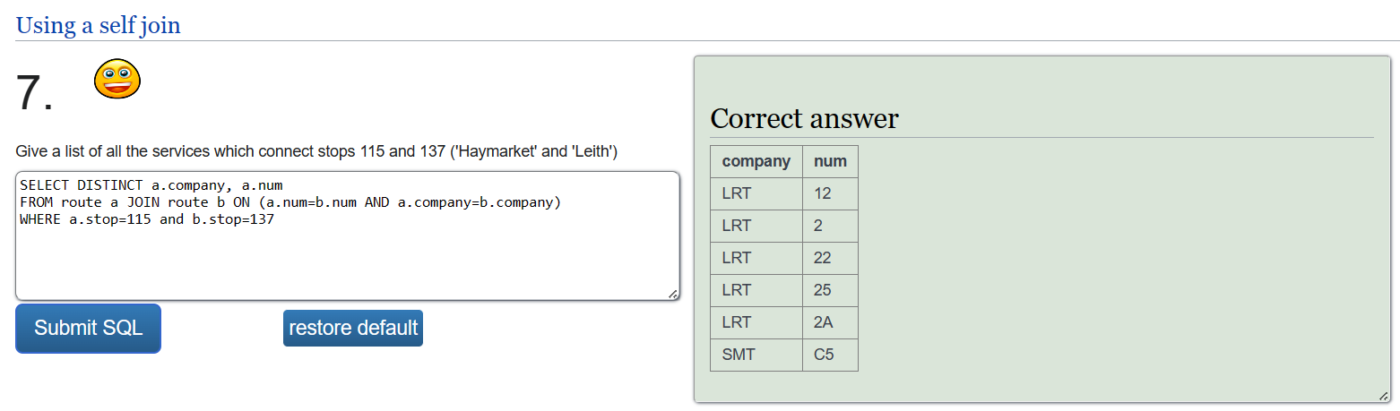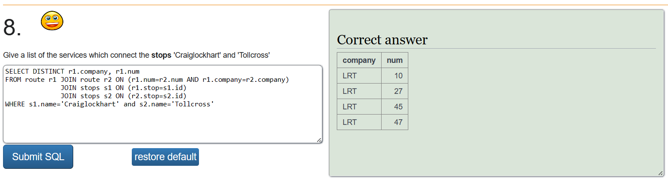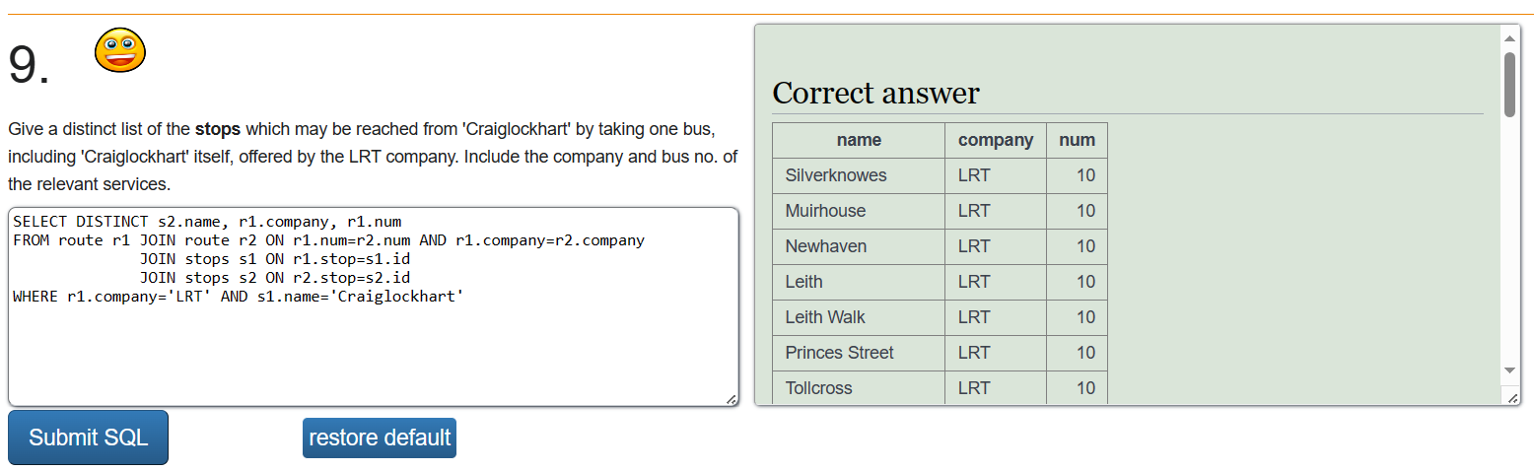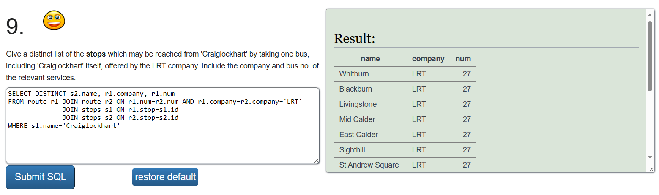

Aynı Numara ve firmadaki otobüslerin gittiği güzergahları birbirleriyle kıyaslıyoruz. Yani num ve company’i sabit tutup name’leri kıyaslıyoruz.

|  |  |  |
| --- | --- | --- |
| s1 | s2 | s3 |
| yer1 | yer2 | yer3 |
| r1 | r2 | r3 |
| no1, comp1 | no2, comp2 | - |

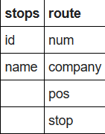

Get from Craiglockhart to Haymarket

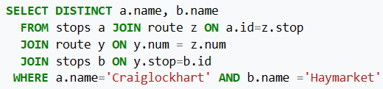

shows the stops that are on route.num '2A' which can be reached with one bus from Haymarket

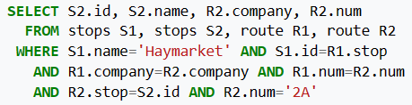

|  |  |  |  |
| --- | --- | --- | --- |
| SQL Server Functions | | | |
| Function | Explanation | Example | Output |
| CAST | converts a data type into another data type | SELECT Cast(10 AS VARCHAR) | 10 |
| COALESCE | returns the first non-null value from a list of expressions | SELECT COALESCE(NULL, 'value2', 'value3') | value2 |
| ISNULL | checks if an expression is null; if it is, it returns a replacement value | SELECT Isnull('value', 'null') | value |
| IFNULL | similar to the is null function, but the arguments are reversed | SELECT Ifnull('value', 'null') | value |
| NVL | replaces null values with a specified default value | SELECT Nvl(NULL, 'default value') | default value |
| CASE | performs conditional operations based on a specified expression | SELECT CASE  WHEN 1 = 1 THEN 'true'  ELSE 'false'  END | TRUE |
| CONVERT | converts a value into a specified data type | SELECT CONVERT(VARCHAR, 10) | 10 |
| STRING_SPLIT | splits a string into a table of substrings | SELECT * FROM String_split('apple,banana,cherry', ',') | apple banana cherry |
| RAND | generates a random number between 0 and 1 | SELECT Rand() | 0.77502473 |
| IF | performs a conditional operation based on a specified expression | SELECT IF(1 = 1, 'true', 'false') | TRUE |
| MID | extracts a substring from a string, starting at a specified position and with a specified length | SELECT Mid('apple', 2, 3) | ppl |
| DATEADD | adds a specified number of intervals to a date | SELECT Dateadd(day, 7, '2023-05-05') | 12.05.2023 |
| DATE_FORMAT | reformats a date value into a string with a specified format | SELECT Date_format('2023-05-05', '%m/%d/%Y') | 5.05.2023 |
|  | SQL String Functions |  |  |
| LEN | return the length of a string | SELECT Len('banana') | 6 |
| LEFT | extracts a specified number of characters from the beginning of a string | SELECT LEFT('banana', 3) | ban |
| RIGHT | extracts a specified number of characters from the end of a string | SELECT RIGHT('banana', 3) | ana |
| TRIM | removes leading and trailing spaces from a string | SELECT Trim(' banana ') | banana |
| ASCII | returns the ASCII code value for a specified character | SELECT Ascii('A') | 65 |
| CONCAT | links two or more strings together | SELECT Concat('apple', 'banana', 'cherry') | applebananacherry |
| FORMAT | reformats a value into a specified string format | SELECT Format(12345.6789, '#,##0.00') | 12,345.68 |
| REPLACE | replaces a specified string with another string in a given expression | SELECT Replace('banana', 'a', 'e') | Benene |
| SUBSTRING | extracts a substring from a given string | SELECT Substring('banana', 2, 3) | man |
| INSTR | finds the position of a specified substring within a string | SELECT Instr('banana', 'a') | 2 |
| STUFF | replaces a substring within a string with another substring | SELECT Stuff('banana', 2, 3, 'oro') | borona |